**Chapter-12**

1. A 30.0-kg hammer, moving with speed 20.0 m/s, strikes a steel spike 2.30 cm in diameter. The hammer rebounds with speed 10.0 m/s after 0.110 s. What is the average strain in the spike during the impact?

A particle under a net force model:



Hence,



By Newton’s third law, this is also the magnitude of the average force exerted on the spike by the hammer during the blow. Thus, the stress in the spike is

Stress 

and the strain is

strain 

1. 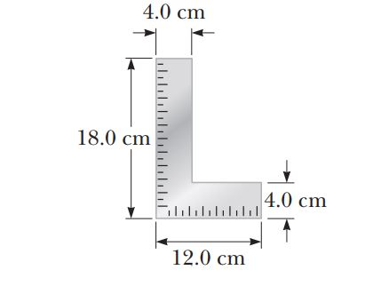A carpenter’s square has the shape of an L as shown in Figure. Locate its center of gravity.

Ans:

The coordinates of the center of gravity of piece 1 are

 and 

The coordinates for piece 2 are

 and 

The area of each piece is

 and 

And the mass of each piece is proportional to the area.

Thus,



and



1. The deepest point in the ocean is in the Mariana Trench, about 11 km deep, in the Pacific. The pressure at this depth is huge, about 1.13 x 108 N/m2. (a) Calculate the change in volume of 1.00 m3 of seawater carried from the surface to this deepest point. (b) The density of seawater at the surface is 1.03 x 103 kg/m3. Find its density at the bottom. (c) Explain whether or when it is a good approximation to think of water as incompressible.

Ans:

We use .

(a) 

(b) The quantity of water with mass  occupies volume at the bottom: 

So its density is  

(c) 