**Chapter-12**

1. A 30.0-kg hammer, moving with speed 20.0 m/s, strikes a steel spike 2.30 cm in diameter. The hammer rebounds with speed 10.0 m/s after 0.110 s. What is the average strain in the spike during the impact?

1. 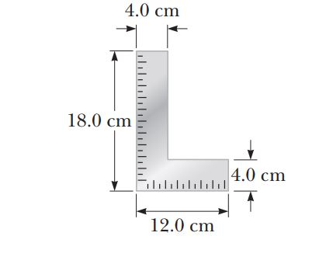A carpenter’s square has the shape of an L as shown in Figure. Locate its center of gravity.

Ans:

1. The deepest point in the ocean is in the Mariana Trench, about 11 km deep, in the Pacific. The pressure at this depth is huge, about 1.13 x 108 N/m2. (a) Calculate the change in volume of 1.00 m3 of seawater carried from the surface to this deepest point. (b) The density of seawater at the surface is 1.03 x 103 kg/m3. Find its density at the bottom. (c) Explain whether or when it is a good approximation to think of water as incompressible.

Ans: