**Chapter-10**

1. A small object with mass 4.00 kg moves counterclockwise with constant angular speed 1.50 rad/s in a circle of radius 3.00 m centered at the origin. It starts at the point with position vector 3.00 ⁄i m. It then undergoes an angular displacement of 9.00 rad. (a) What is its new position vector? Use unit-vector notation for all vector answers. (b) In what quadrant is the particle located, and what angle does its position vector make with the positive x axis? (c) What is its velocity? (d) In what direction is it moving? (e) What is its acceleration? (f) Make a sketch of its position, velocity, and acceleration vectors. (g) What total force is exerted on

The object starts with  The location of its final position on the circle is found from 

(a) Its position vector is



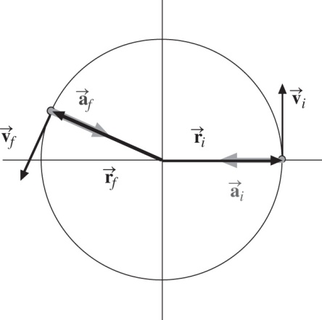

**ANS. FIG. P10.12**

(b) 

(c) The object’s velocity is (1.50 rad/s)(3.00 m) = 4.50 m/s at 90°. After the displacement, its velocity is



(d) .

(e) Its acceleration is v2/r, opposite in direction to its position vector. This is



(f) ANS. FIG. P10.12 shows the initial and final position, velocity, and acceleration vectors.

(g) The total force is given by



1. Why is the following situation impossible? In a large city with an air-pollution problem, a bus has no combustion engine. It runs over its citywide route on energy drawn from a large, rapidly rotating flywheel under the floor of the bus. The flywheel is spun up to its maximum rotation rate of 3 000 rev/min by an electric motor at the bus terminal. Every time the bus speeds up, the flywheel slows down slightly. The bus is equipped with regenerative braking so that the flywheel can speed up when the bus slows down. The flywheel is a uniform solid cylinder with mass 1 200 kg and radius 0.500 m. The bus body does work against air resistance and rolling resistance at the average rate of 25.0 hp as it travels its route with an average speed of 35.0 km/h.

The power output of the bus is  where



is the stored energy and  is the time it can roll. Then  The maximum range of the bus is then 

For average  and average   
*v* =35.0 km/h = 9.72 m/s, the maximum range is





1. A metal can containing condensed mushroom soup has mass 215 g, height 10.8 cm, and diameter 6.38 cm. It is placed at rest on its side at the top of a 3.00-m-long incline that is at 25.0o to the horizontal and is then released to roll straight down. It reaches the bottom of the incline after 1.50 s.(a) Assuming mechanical energy conservation, calculate the moment of inertia of the can. (b) Which pieces of data, if any, are unnecessary for calculating the solution? (c) Why can’t the moment of inertia be calculated from I 2  for the cylindrical can?

(a) For the isolated can-Earth system,



which gives



From the particle under constant acceleration model,



Therefore, the moment of inertia is



Substitute numerical values:



(b) The  is unnecessary data.

(c) 

**Chapter-11**

1. A particle is located at a point described by the position vector $\vec{r}$ = (4.00 $\hat{i}$ + 6.00 $\hat{j}$) m, and a force exerted on it is given by $\vec{F}$ ( 3.00 $\hat{i}$ + 2.00 $\hat{j}$) N. (a) What is the torque acting on the particle about the origin? (b) Can there be another point about which the torque caused by this force on this particle will be in the opposite direction and half as large in magnitude? (c) Can there be more than one such point? (d) Can such a point lie on the y axis? (e) Can more than one such point lie on the y axis? (f) Determine the position vector of one such point.

(a) The torque acting on the particle about the origin is



(b) 

(c) 

(d) 

(e) 

(f) Let (0, *y*) represent the coordinates of the special axis of rotation located on the *y* axis of Cartesian coordinates. Then the displacement from this point to the particle feeling the force is  in meters. The torque of the force about this new axis is



Then,



The position vector of the new axis is 

1. A uniform cylindrical turntable of radius 1.90 m and mass 30.0 kg rotates counterclockwise in a horizontal plane with an initial angular speed of 4 $π$ rad/s. The fixed turntable bearing is frictionless. A lump of clay of mass 2.25 kg and negligible size is dropped onto the turntable from a small distance above it and immediately sticks to the turntable at a point 1.80 m to the east of the axis. (a) Find the final angular speed of the clay and turntable. (b) Is the mechanical energy of the turntable– clay system constant in this process? Explain and use numerical results to verify your answer. (c) Is the momentum of the system constant in this process? Explain your answer

(a) We solve by using conservation of angular momentum for the turntable-clay system, which is isolated from outside torques:



Solving for the final angular velocity gives



(b)  The initial energy is



The final mechanical energy is



Thus 507 J of mechanical energy is transformed into internal energy. The “angular collision” is completely inelastic.

(c) No. The original horizontal momentum is zero. As soon as the clay has stopped skidding on the turntable, the final momentum is (2.25 kg)(1.80 m)(11.1 rad/s) = 44.9 kg · m/s north. This is the amount of impulse injected by the bearing. The bearing thereafter keeps changing the system momentum to change the direction of the motion of the clay. The turntable bearing promptly imparts an impulse of 44.9 kg · m/s north into the turntable-clay system, and thereafter keeps changing the system momentum.

1. A thin, uniform, rectangular signboard hangs vertically above the door of a shop. The sign is hinged to a stationary horizontal rod along its top edge. The mass of the sign is 2.40 kg, and its vertical dimension is 50.0 cm. The sign is swinging without friction, so it is a tempting target for children armed with snowballs. The maximum angular displacement of the sign is 25.08 on both sides of the vertical. At a moment when the sign is vertical and moving to the left, a snowball of mass 400 g, traveling horizontally with a velocity of 160 cm/s to the right, strikes perpendicularly at the lower edge of the sign and sticks there. (a) Calculate the angular speed of the sign immediately before the impact. (b) Calculate its angular speed immediately after the impact. (c) The spattered sign will swing up through what maximum angle?

(a) Let *ω* be the angular speed of the signboard   
when it is vertical.



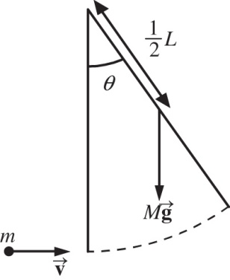

**ANS. FIG. P11.33**

(b)  represents angular momentum conservation for the sign-snowball system. Substituting into the above equation,



Solving,



(c) Let  distance of center of mass from the axis of rotation.



Applying conservation of mechanical energy,



Solving for  then gives

