**Chapter-1**

1. Two spheres are cut from a certain uniform rock. One has radius 4.50 cm. The mass of the other is five times greater. Find its radius

Ans. For either sphere the volume is  and the mass is  We divide this equation for the larger sphere by the same equation for the smaller:



Then 

1. One cubic meter (1.00 m3) of aluminum has a mass of 2.70 X 103 kg, and the same volume of iron has a mass of 7.86 X 103 kg. Find the radius of a solid aluminum sphere that will balance a solid iron sphere of radius 2.00 cm on an equal-arm balance

Ans: The aluminum sphere must be larger in volume to compensate for its lower density. We require equal masses:



then use the volume of a sphere. By substitution,



Now solving for the unknown,



Taking the cube root, 

The aluminum sphere is 43% larger than the iron one in radius, diameter, and circumference. Volume is proportional to the cube of the linear dimension, so this excess in linear size gives it the (1.43)(1.43)(1.43) = 2.92 times larger volume it needs for equal mass.

**Chapter-2**

1. A car travels along a straight line at a constant speed of 60.0 mi/h for a distance *d* and then another distance *d* in the same direction at another constant speed. The average velocity for the entire trip is 30.0 mi/h. (a) What is the constant speed with which the car moved during the second distance *d*? (b) **What If?** Suppose the second distance *d* were traveled in the opposite direction; you forgot something and had to return home at the same constant speed as found in part (a). What is the average velocity for this trip? (c) What is the average speed for this new trip?

**Ans:** The trip has two parts: first the car travels at constant speed *v*1 for distance *d*, then it travels at constant speed *v*2 for distance *d*. The first part takes the time interval  = *d/v*1, and the second part takes the time interval ∆*t*2 = *d/v*2.

(a) By definition, the average velocity for the entire trip is  where  and  Putting these together, we have



We know *v*avg = 30 mi/h and *v*1 = 60 mi/h.

Solving for *v*2 gives



(b) The average velocity for this trip is  where   
 so, *v*avg=

(c) The average speed for this trip is where *d* = *d*1 + *d*2 =   
*d* + *d* = 2*d* and  so, the average speed is the same as in part (a): *v*avg = 

1. At *t* = 0, one toy car is set rolling on a straight track with initial position 15.0 cm, initial velocity 23.50 cm/s, and constant acceleration 2.40 cm/s2. At the same moment, another toy car is set rolling on an adjacent track with initial position 10.0 cm, initial velocity 15.50 cm/s, and constant acceleration zero. (a) At what time, if any, do the two cars have equal speeds? (b) What are their speeds at that time? (c) At what time(s), if any, do the cars pass each other? (d) What are their locations at that time? (e) Explain the difference between question (a) and question (c) as clearly as possible.?

**Ans:** (a) For the first car, the speed as a function of time is



For the second car, the speed is

**

Setting the two expressions equal gives



Solving for *t* gives



(b) The first car then has speed



and this is also the constant speed of the second car.

(c) For the first car, the position as a function of time is

**

For the second car, the position is

**

At the point where the cars pass one another, their positions are equal:



rearranging gives



We solve this with the quadratic formula. Suppressing units,



(d) At *t* = 0.604 s, the second and also the first car’s position is

**

At *t* = 6.90 s, both are at position



**Chapter-3**

1. A man pushing a mop across a floor causes it to undergo two displacements. The first has a magnitude of 150 cm and makes an angle of 120o with the positive *x* axis. The resultant displacement has a magnitude of 140 cm and is directed at an angle of 35.0o to the positive *x* axis Find the magnitude and direction of the second displacement.

**Ans:** We will use the component method for a precise answer. We already know the total displacement, so the algebra of solving a vector equation will guide us to do a subtraction.

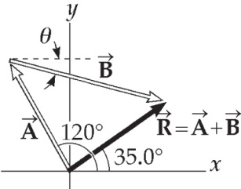 We have 

*Ax* = 150 cos 120° = *−*75.0 cm

*Ay* = 150 sin 120° = 130 cm

**ans. Fig. P3.27**

*Rx* = 140 cos 35.0° = 115 cm

*Ry* = 140 sin 35.0° = 80.3 cm

Therefore,



1. Vectors **A** and **B** have equal magnitudes of 5.00. The sum of **A** and **B** is the vector 6.00 **j**. Determine the angle between **A** and **B**

Ans: Since

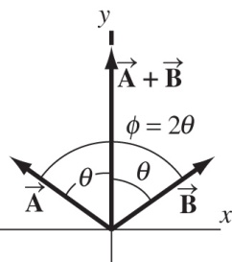 

we have



**ans. Fig. P3.44**

giving 

Because the vectors have the same magnitude and *x* components of equal magnitude but of opposite sign, the vectors are reflections of each other in the *y* axis, as shown in the diagram. Therefore, the two vectors have the same *y* components:

*Ay* = *By* = (1/2)(6.00) = 3.00

Defining *θ* as the angle between either  or  and the *y* axis, it is seen that



The angle between  and  is then 

**Chapter-4**

1. A projectile is fired in such a way that its horizontal range is equal to three times its maximum height. What is the angle of projection?

Ans: We ignore the trivial case where the angle of projection equals zero degrees.



so 

or 

thus, 

1. The pilot of an airplane notes that the compass indicates a heading due west. The airplane’s speed relative to the air is 150 km/h. The air is moving in a wind at 30.0 km/h toward the north. Find the velocity of the airplane relative to the ground.

Ans: The westward speed of the airplane is the horizontal component of its velocity vector, and the northward speed of the wind is the vertical component of its velocity vector, which has magnitude and direction given by





**Chapter-5**

1. A simple accelerometer is constructed inside a car by suspending an object of mass *m* from a string of length *L* that is tied to the car’s ceiling. As the car accelerates the string– object system makes a constant angle of *u* with the vertical. (a) Assuming that the string mass is negligible compared with *m*, derive an expression for the car’s acceleration in terms of *u* and show that it is independent of the mass *m* and the length *L*. (b) Determine the acceleration of the car when *θ=* 23.0°.

Ans: (a) Assume the car and mass accelerate horizontally. We consider the forces on the suspended object.

 

 

Substitute  from the first equation into the second,

**ANS. FIG. P5.21**





(b) 

1. A 9.00-kg hanging object is connected by a light, inextensible cord over a light, frictionless pulley to a 5.00-kg block that is sliding on a flat table (Fig. P5.22). Taking the coefficient of kinetic friction as 0.200, find the tension in the string

Ans: Newton’s second law for the 5.00-kg mass gives

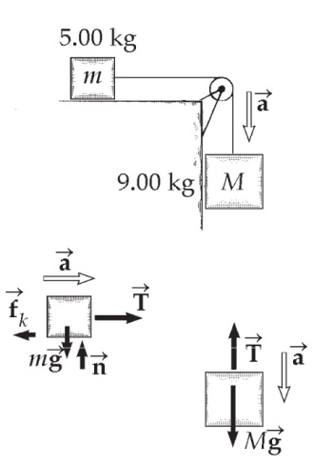 *T* – *fk* = (5.00 kg)*a*

Similarly, for the 9.00-kg mass,

(9.00 kg)*g* – *T* = (9.00 kg)*a*

Adding these two equations gives:



ANS. FIG.P5.29

Which yields *a* = 5.60 m/s2. Plugging this into   
the first equation above gives



**Chapter-6**

1. A small, spherical bead of mass 3.00 g is released from rest at *t* = 0 from a point under the surface of a viscous liquid. The terminal speed is observed to be *vr* = 2.00 cm/s. Find (a) the value of the constant *b* that appears in Equation 6.2, (b) the time *t* at which the bead reaches 0.632*vr*, and (c) the value of the resistive force when the bead reaches terminal speed

**Ans:** We have a particle under a net force in the special case of a resistive force proportional to speed, and also under the influence of the gravitational force.

(a) The speed *v* varies with time according to Equation 6.6,



where *vT* = *mg*/*b* is the terminal speed. Hence,



(b) To find the time interval for *v* to reach 0.632*vT*, we substitute   
*v* = 0.632*vT* into Equation 6.6, giving

0.632*vT* = *vT* (1 − *e*−*bt*/*m*) or 0.368 = *e*−(1.47*t*/0.003 00)

Solve for *t* by taking the natural logarithm of each side of the equation:



or 

(c) At terminal speed, *R* = *vTb* = *mg.* Therefore,



1. A car of mass *m* passes over a hump in a road that follows the arc of a circle of radius *R* as shown in Figure P6.26. (a) If the car travels at a speed *v*, what force does the road exert on the car as the car passes the highest point of the hump? (b) **What If?** What is the maximum speed the car can have without losing contact with the road as it passes this highest point?

**Ans:** (a) The free-body diagram in ANS. FIG. P6.26 shows the forces on the car in the vertical direction. Newton’s second law then gives



 

(b) When *n* = 0, 

Then, 

A more gently curved bump, with larger radius, allows the car to have a higher speed without leaving the road. This speed is proportional to the square root of the radius.