**Chapter-1**

1. Two spheres are cut from a certain uniform rock. One has radius 4.50 cm. The mass of the other is five times greater. Find its radius

Ans.

1. One cubic meter (1.00 m3) of aluminum has a mass of 2.70 X 103 kg, and the same volume of iron has a mass of 7.86 X 103 kg. Find the radius of a solid aluminum sphere that will balance a solid iron sphere of radius 2.00 cm on an equal-arm balance

Ans:

.

**Chapter-2**

1. A car travels along a straight line at a constant speed of 60.0 mi/h for a distance *d* and then another distance *d* in the same direction at another constant speed. The average velocity for the entire trip is 30.0 mi/h. (a) What is the constant speed with which the car moved during the second distance *d*? (b) **What If?** Suppose the second distance *d* were traveled in the opposite direction; you forgot something and had to return home at the same constant speed as found in part (a). What is the average velocity for this trip? (c) What is the average speed for this new trip?

**Ans:**

1. At *t* = 0, one toy car is set rolling on a straight track with initial position 15.0 cm, initial velocity 23.50 cm/s, and constant acceleration 2.40 cm/s2. At the same moment, another toy car is set rolling on an adjacent track with initial position 10.0 cm, initial velocity 15.50 cm/s, and constant acceleration zero. (a) At what time, if any, do the two cars have equal speeds? (b) What are their speeds at that time? (c) At what time(s), if any, do the cars pass each other? (d) What are their locations at that time? (e) Explain the difference between question (a) and question (c) as clearly as possible.?

**Ans:**

**Chapter-3**

1. A man pushing a mop across a floor causes it to undergo two displacements. The first has a magnitude of 150 cm and makes an angle of 120o with the positive *x* axis. The resultant displacement has a magnitude of 140 cm and is directed at an angle of 35.0o to the positive *x* axis Find the magnitude and direction of the second displacement.

**Ans:**

1. Vectors **A** and **B** have equal magnitudes of 5.00. The sum of **A** and **B** is the vector 6.00 **j**. Determine the angle between **A** and **B**

Ans:

**Chapter-4**

1. A projectile is fired in such a way that its horizontal range is equal to three times its maximum height. What is the angle of projection?

Ans:

1. The pilot of an airplane notes that the compass indicates a heading due west. The airplane’s speed relative to the air is 150 km/h. The air is moving in a wind at 30.0 km/h toward the north. Find the velocity of the airplane relative to the ground.

Ans:

**Chapter-5**

1. A simple accelerometer is constructed inside a car by suspending an object of mass *m* from a string of length *L* that is tied to the car’s ceiling. As the car accelerates the string– object system makes a constant angle of *u* with the vertical. (a) Assuming that the string mass is negligible compared with *m*, derive an expression for the car’s acceleration in terms of *u* and show that it is independent of the mass *m* and the length *L*. (b) Determine the acceleration of the car when *θ=* 23.0°.

Ans:

1. 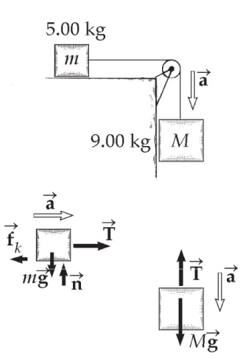A 9.00-kg hanging object is connected by a light, inextensible cord over a light, frictionless pulley to a 5.00-kg block that is sliding on a flat table (Fig. P5.22). Taking the coefficient of kinetic friction as 0.200, find the tension in the string

Ans:

**Chapter-6**

1. A small, spherical bead of mass 3.00 g is released from rest at *t* = 0 from a point under the surface of a viscous liquid. The terminal speed is observed to be *vr* = 2.00 cm/s. Find (a) the value of the constant *b* that appears in Equation 6.2, (b) the time *t* at which the bead reaches 0.632*vr*, and (c) the value of the resistive force when the bead reaches terminal speed

**Ans:**

1. A car of mass *m* passes over a hump in a road that follows the arc of a circle of radius *R* as shown in Figure P6.26. (a) If the car travels at a speed *v*, what force does the road exert on the car as the car passes the highest point of the hump? (b) **What If?** What is the maximum speed the car can have without losing contact with the road as it passes this highest point?

**Ans:**