

**General Physics-I, Quiz 3**

PHYS1000AA, AB, AC Fall-Semester-109

2020-12-17

Department of Physics

National Dong Hwa University, 1, Sec. 2,

Da Hsueh Rd., Shou-Feng, Hualien, 97401, Taiwan

St. ID: , Name:

1. (a) What is the minimum speed, relative to the Sun, necessary for a spacecraft to escape the solar system if it starts at the Earth’s orbit? (b) Voyager 1 achieved a maximum speed of 125 000 km/h on its way to photograph Jupiter. Beyond what distance from the Sun is this speed sufficient to escape the solar system?

(a) The escape velocity from the solar system, starting at Earth’s orbit, is given by



(b) Let *x* represent the variable distance from the Sun. Then,



If  then



Note that at or beyond the orbit of Mars, 125 000 km/h is sufficient for escape.

1. 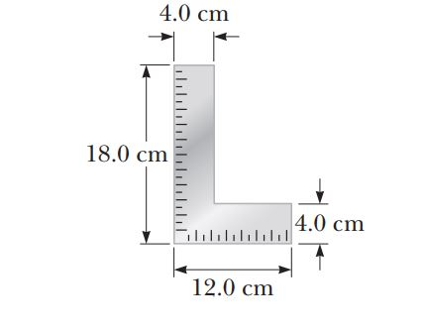A carpenter’s square has the shape of an L as shown in Figure. Locate its center of gravity.

Ans:

The coordinates of the center of gravity of piece 1 are

 and 

The coordinates for piece 2 are

 and 

The area of each piece is

 and 

And the mass of each piece is proportional to the area.

Thus,



and

