

**General Physics-I, Quiz 3**

PHYS1000AA, AB, AC Fall-Semester-109

2020-12-17

Department of Physics

National Dong Hwa University, 1, Sec. 2,

Da Hsueh Rd., Shou-Feng, Hualien, 97401, Taiwan

St. ID: , Name:

1. (a) What is the minimum speed, relative to the Sun, necessary for a spacecraft to escape the solar system if it starts at the Earth’s orbit? (b) Voyager 1 achieved a maximum speed of 125 000 km/h on its way to photograph Jupiter. Beyond what distance from the Sun is this speed sufficient to escape the solar system?

1. 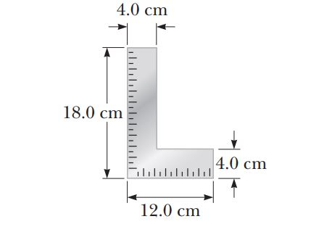A carpenter’s square has the shape of an L as shown in Figure. Locate its center of gravity.

Ans: