

**General Physics-I, Quiz 2**

PHYS1000AA, AB, AC Fall-Semester-109

2020-11-12

Department of Physics

National Dong Hwa University, 1, Sec. 2,

Da Hsueh Rd., Shou-Feng, Hualien, 97401, Taiwan

St. ID: , Name:

**Chapter 7**

1. A thin, uniform, rectangular signboard hangs vertically above the door of a shop. The sign is hinged to a stationary horizontal rod along its top edge. The mass of the sign is 2.40 kg, and its vertical dimension is 50.0 cm. The sign is swinging without friction, so it is a tempting target for children armed with snowballs. The maximum angular displacement of the sign is 25.08 on both sides of the vertical. At a moment when the sign is vertical and moving to the left, a snowball of mass 400 g, traveling horizontally with a velocity of 160 cm/s to the right, strikes perpendicularly at the lower edge of the sign and sticks there. (a) Calculate the angular speed of the sign immediately before the impact. (b) Calculate its angular speed immediately after the impact. (c) The spattered sign will swing up through what maximum angle?

(a) Let *ω* be the angular speed of the signboard   
when it is vertical.



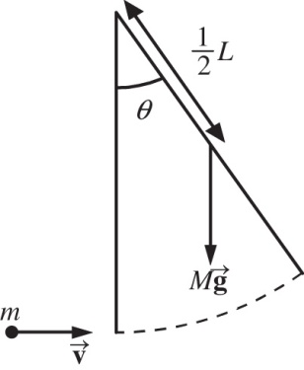

**ANS. FIG. P11.33**

(b)  represents angular momentum conservation for the sign-snowball system. Substituting into the above equation,



Solving,



(c) Let  distance of center of mass from the axis of rotation.



Applying conservation of mechanical energy,



Solving for  then gives

1. 