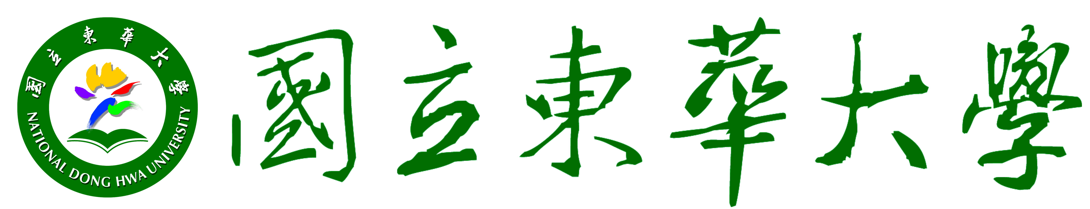
National Dong Hwa University International Student Scholarship Regulations

96.3.14. approved; 1st Administrative Council
96.4.25 approved; 4th Administrative Council
97.12.12 approved; International Student Exam Committee
98.1.7 amended and approved; 7th Administrative Council
99.10.27 amended and approved; 3rd Administrative Council

Article 1 The following regulations (hereinafter referred to as the Regulations) are established to promote the international recognition of National Dong Hwa University (hereinafter referred to as NDHU), to attract international students with exceptional academic performance, and to award international students that have achieved outstanding performance in NDHU.
Article 2 Application forms shall be submitted to the Office of Academic Affairs for preliminary review; secondary review shall be conducted by the International Student Admission Committee, which then submits a list of recommended candidates to the NDHU President.
Article 3 The term, international student(s), addressed by the Regulations is defined as neither R.O.C. citizens nor overseas Chinese.
Article 4 Number of Persons and Types:
- Number of Persons: The total number is subject to the annual budget.
- Types:
  - Tuition Waiver: Full tuition and students fees covered.
  - Stipend: NT$ 30,000 per academic year for Bachelor-level students, NT$ 50,000 for Master-level students, NT$ 60,000 for Ph.D. students.
Article 5 Application Requirements:
- New Students: Formally admitted by NDHU as international students.
In addition to covering tuition waiver, the awarded students may also be given stipend subject to the documents and academic records submitted (those, who take transnational dual degree programs are included).
- Currently Enrolled Students: Those, who have completed one semester of full-time study.
  - Tuition Waiver:
    - Graduates: Having completed at least 3 credits each semester, an average GPA of 3.3 or above, no record of severe personal misconduct.
    - Undergraduates: Having completed at least 9 credits each semester, an average GPA of 3.3 or above, moral score of 80 or above, no record of severe personal misconduct.
  - Stipend: Those, who are qualified for tuition waiver, can apply for stipend with an average GPA above 3.7.
  - Ph.D. or Master-level students, who are at the thesis-writing stage hence without any academic record of the previous semester, can apply no later than the deadline by producing a piece of thesis proposal stating research purpose and objectives, research structure and design, data collection and resources, thesis outline, references, etc.
- Applicants must not be a recipient of any R.O.C. government scholarship or student-aid.
Article 6 Application Procedures:
- New Students: All the documents submitted for admission to studying in NDHU will be regarded as criteria for reviewing the scholarship application as well.
- Currently Enrolled Students: Submit the following documents by August 31st every year.
  - Application form for NDHU International Student Scholarship.
  - Previous Transcripts in NDHU.
  - Thesis proposal (only for those, who have no transcript for the semester before the period of writing doctoral or master thesis).
Article 7 Duration, Number of Years, Process:
- Duration for the Scholarship covering tuition waiver and/or stipend is one year; for Spring Class only, one semester. NDHU students must (re-)apply every year.
- Awarded students of stipend will receive the grants in semester one (September ~ January) and semester two (February ~ June) respectively. The grant will be remitted monthly by Office of Student Affairs to the awarded student’s account at local bank/post office (Bachelor-level students: NT$ 3,000; Master-level students: NT$ 5,000; Ph.D. students: NT$ 6,000).
- Limitation in the number of years for receiving the Scholarship covering tuition waiver and/or stipend is four years per Bachelor-level student, two years per Master-level student, 3 years per Ph.D. student; not necessarily consecutive.
Article 8 Awarded students must comply with the following regulations and duties:
- Registration must be completed no later than the deadline officially announced by NDHU.
- Awarded students of the Scholarship covering both tuition waiver and stipend must not apply for related concessions the following year once failing to meet the requirements stated in Article 5.
- Awarded students will be disqualified upon suspension and/or dismission of schooling. The grant will be terminated from the next month of leaving NDHU.
- New students awarded the Scholarship must not apply for admission reservation unless with special incidents and approved by the International Student Admission Committee.
Article 9 Awarded students will be disqualified upon producing forged and/or false documents, or receiving other scholarships or student-aid at the same time. The Scholarship already granted must be returned.
Article 10 The funding of the Scholarship shall be allotted from NDHU’s budget for scholarships.
Article 11 NDHU reserves the right to make changes that affect the abovementioned policies, fees, curricula, or other matters according to related regulations of NDHU, or the Ministry of Education in Taiwan.
Article 12 The Regulations have been reviewed by the Administrative Council, and approved by the President; any amendments shall be processed accordingly.

Annotations:
- The new version of the Regulations is to be commenced from the second semester of 2010/2011; the original version is to be terminated with the current semester, i.e. the first semester of 2010/2011.
- The grading of NDHU is: A+ (4.5), A (4.0), A- (3.7), and B+ (3.3).
- International students, who have been admitted by NDHU for 99-1 (and before) and meet the requirements stated in Article 5, can apply for the Scholarship. Please refer to Article 6 for application procedures.
---- 以下空白-----

