Chapter – 8
- Energy is conventionally measured in Calories as well as in joules. One Calorie in nutrition is one kilocalorie, defined as 1 kcal = 4 186 J. Metabolizing 1 g of fat can release 9.00 kcal. A student decides to try to lose weight by exercising. He plans to run up and down the stairs in a football stadium as fast as he can and as many times as necessary. To evaluate the program, suppose he runs up a flight of 80 steps, each 0.150 m high, in 65.0 s. For simplicity, ignore the energy he uses in coming down (which is small). Assume a typical efficiency for human muscles is 20.0%. This statement means that when your body converts 100 J from metabolizing fat, 20 J goes into doing mechanical work (here, climbing stairs). The remainder goes into extra internal energy. Assume the student’s mass is 75.0 kg. (a) How many times must the student run the flight of stairs to lose 1.00 kg of fat? (b) What is his average power output, in watts and in horsepower, as he runs up the stairs? (c) Is this activity in itself a practical way to lose weight?
Solution:

- Jonathan is riding a bicycle and encounters a hill of height 7.30 m. At the base of the hill, he is traveling at 6.00 m/s. When he reaches the top of the hill, he is traveling at 1.00 m/s. Jonathan and his bicycle together have a mass of 85.0 kg. Ignore friction in the bicycle mechanism and between the bicycle tires and the road. (a) What is the total external work done on the system of Jonathan and the bicycle between the time he starts up the hill and the time he reaches the top? (b) What is the change in potential energy stored in Jonathan’s body during this process? (c) How much work does Jonathan do on the bicycle pedals within the Jonathan–bicycle–Earth system during this process?
Solution:

Chapter – 9
- Two blocks of masses m and 3m are placed on a frictionless, horizontal surface. A light spring is attached to the more massive block, and the blocks are pushed together with the spring between them (Fig. P9.5). A cord initially holding the blocks together is burned; after that happens, the block of mass 3m moves to the right with a speed of 2.00 m/s. (a) What is the velocity of the block of mass m? (b) Find the system’s original elastic potential energy, taking m = 0.350 kg. (c) Is the original energy in the spring or in the cord? (d) Explain your answer to part (c). (e) Is the momentum of the system conserved in the bursting-apart process? Explain how that is possible considering (f) there are large forces acting and (g) there is no motion beforehand and plenty of motion afterward?
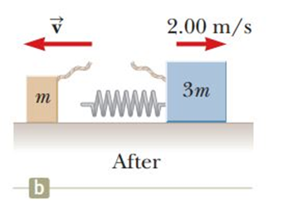
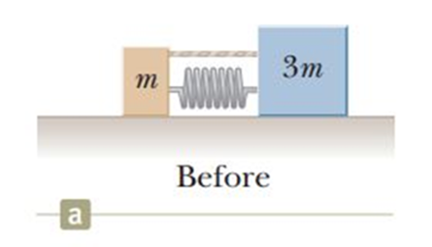

Solution:

2. A 90.0-kg fullback running east with a speed of 5.00 m/s is tackled by a 95.0-kg opponent running north with a speed of 3.00 m/s. (a) Explain why the successful tackle constitutes a perfectly inelastic collision. (b) Calculate the velocity of the players immediately after the tackle. (c) Determine the decrease in mechanical energy as a result of the collision. Account for this decrease.
Solution:

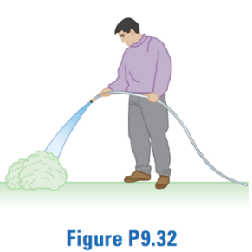
3. A garden hose is held as shown in Figure P9.32. The hose is originally full of motionless water. What additional force is necessary to hold the nozzle stationary after the water flow is turned on if the discharge rate is 0.600 kg/s with a speed of 25.0 m/s?
Solution:

