Chapter - 7

- When a 4.00-kg object is hung vertically on a certain light spring that obeys Hooke’s law, the spring stretches 2.50 cm. If the 4.00-kg object is removed, (a) how far will the spring stretch if a 1.50-kg block is hung on it? (b) How much work must an external agent do to stretch the same spring 4.00 cm from its unstretched position?
Solution:

- A 0.20-kg stone is held 1.3 m above the top edge of a water well and then dropped into it. The well has a depth of 5.0 m. Relative to the configuration with the stone at the top edge of the well, what is the gravitational potential energy of the stone–Earth system (a) before the stone is released and (b) when it reaches the bottom of the well? (c) What is the change in gravitational potential energy of the system from release to reaching the bottom of the well?
Solution:

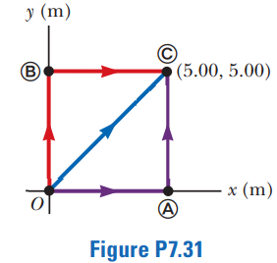
3. A 4.00-kg particle moves from the origin to position Ⓒ, having coordinates x = 5.00 m and y = 5.00 m (Fig. P7.31). One force on the particle is the gravitational force acting in the negative y direction. Using Equation 7.3, calculate the work done by the gravitational force on the particle as it goes from O to Ⓒ along (a) the purple path, (b) the red path, and (c) the blue path. (d) Your results should all be identical. Why?
Solution:

4. The potential energy of a system of two particles separated by a distance r is given by U(r) = A/r, where A is a constant. Find the radial force $F_{r}$ that each particle exerts on the other.
Solution:

Chapter - 8

1. A ball of mass m falls from a height h to the floor. (a) Write the appropriate version of Equation 8.2 for the system of the ball and the Earth and use it to calculate the speed of the ball just before it strikes the Earth. (b) Write the appropriate version of Equation 8.2 for the system of the ball and use it to calculate the speed of the ball just before it strikes the Earth.
Solution:

2. An energy-efficient lightbulb, taking in 28.0 W of power, can produce the same level of brightness as a conventional lightbulb operating at power 100 W. The lifetime of the energy-efficient bulb is 10 000 h and its purchase price is $4.50, whereas the conventional bulb has a lifetime of 750 h and costs $0.42. Determine the total savings obtained by using one energy-efficient bulb over its lifetime as opposed to using conventional bulbs over the same time interval. Assume an energy cost of $0.200 per kilowatt-hour.
Solution:

