**Chapter-32**

1. 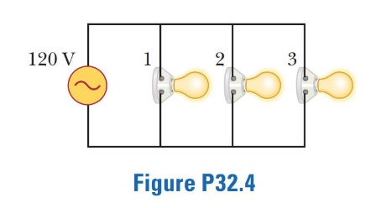Figure P32.4 shows three lightbulbs connected to a 120-V AC (rms) household supply voltage. Bulbs 1 and 2 have a power rating of 150 W, and bulb 3 has a 100-W rating. Find (a) the rms current in each bulb and (b) the resistance of each bulb. (c) What is the total resistance of the combination of the three lightbulbs?

All lamps are connected in parallel with the voltage source, so   
 for each lamp. Also, the current is  and the resistance is .

(a) For the 150-W bulbs,



For the 100-W bulb,

 

The rms current in each 150-W bulb is 1.25 A. The rms current in the 100-W bulb is 0.833 A.

(b) The resistance in bulbs 1 and 2 is



and the resistance in bulb 3 is

 

(c) The bulbs are in parallel, so



1. An AC source with Δ*V* max = 150 V and *f* = 50.0 Hz is connected between points *a* and *d* in Figure P32.16. Calculate the maximum voltages between (a) points *a* and *b*, (b) points *b* and *c*, (c) points *c* and *d*, and (d) points *b* and *d*

We first determine the reactances of the circuit. The capacitive reactance is

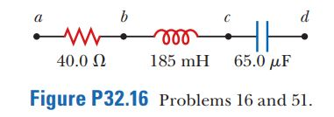

the inductive reactance is,



and the impedance Z of the circuit is



The current in the circuit is then



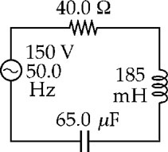

**ANS. FIG. P32.16**

(a) The maximum voltage between points *a* and *b* is the potential drop across the resistor:



(b) The maximum voltage between points *b* and *c* is the potential drop across the coil:



(c) The maximum voltage between points *c* and *d* is the potential drop across the capacitor:



(d) The potential drop between points *b* and *d* is



1. A 60.0-Ω resistor is connected in series with a 30.0-*µ*F capacitor and a source whose maximum voltage is 120 V, operating at 60.0 Hz. Find (a) the capacitive reactance of the circuit, (b) the impedance of the circuit, and (c) the maximum current in the circuit. (d) Does the voltage lead or lag the current? (e) How will adding an inductor in series with the existing resistor and capacitor affect the current? Explain

Ans : (a) The capacitive reactance of the circuit is



(b) The impedance of the circuit is



(c) 

(d) The phase angle in this *RC* circuit is



Since , .

(e) 

1. A series *RLC* circuit has components with the following values: *L =* 20.0 mH, *C* = 100 nF, *R* = 20.0 Ω, and Δ*V* max = 100 V, with Δ*ν* = Δ*V*max sin *ωt.* Find (a) the resonant frequency of the circuit, (b) the amplitude of the current at the resonant frequency, (c) the *Q* of the circuit, and (d) the amplitude of the voltage across the inductor at resonance.

Ans: We are given *L* = 0.020 0 H, *C* = 100 × 10–9 F, *R* = 20.0 Ω, and   


(a) The resonant frequency for a series *RLC* circuit is

 

(b) At resonance,



(c) From Equation 32.43,



(d) At resonance, the amplitude of the voltage across the inductor is

