**Chapter-29**

1. One long wire carries current 30.0 A to the left along the *x* axis. A second long wire carries current 50.0 A to the right along the line (*y* = 0.280 m, *z* = 0). (a) Where in the plane of the two wires is the total magnetic field equal to zero? (b) A particle with a charge of -2.00 *µ*C is moving with a velocity of 150 $\hat{i}$ Mm/s along the line (*y* = 0.100 m, *z* = 0). Calculate the vector magnetic force acting on the particle. (c) **What If?** A uniform electric field is applied to allow this particle to pass through this region undeflected. Calculate the required vector electric field.

(a) Above the pair of wires, the field out of the page of the 50.0-A current will be stronger than the  field of the 29.0-A current, so they cannot add to zero. Between the wires, both produce fields into the page. They can only add to zero below the wires, at coordinate *y* = –⎮*y*⎮. Here the total field is

 48573-30-12a2  48573-30-12a3:



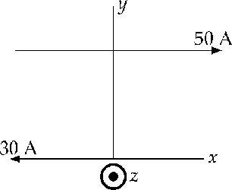

**ANS. FIG. P29.8**

(b) At *y* = 0.100 m the total field is

 48573-30-12b1  48573-30-12b2:



The force on the particle is



(c) We require 

so 

1. Two long wires hang vertically. Wire 1 carries an upward current of 1.50 A. Wire 2, 20.0 cm to the right of wire 1, carries a downward current of 4.00 A. A third wire, wire 3, is to be hung vertically and located such that when it carries a certain current, each wire experiences no net force. (a) Is this situation possible? Is it possible in more than one way? Describe (b) the position of wire 3 and (c) the magnitude and direction of the current in wire 3.

Carrying oppositely directed currents, wires 1 and 2 repel each other. If wire 3 were between them, it would have to repel either 1 or 2, so the force on that wire could not be zero. If wire 3 were to the right of wire 2, it would feel a larger force exerted by 2 than that exerted by 1, so the total force on 3 could not be zero. Therefore wire 3 must be to the left of both other wires as shown. It must carry downward current so that it can attract wire 2. We answer part (b) first.

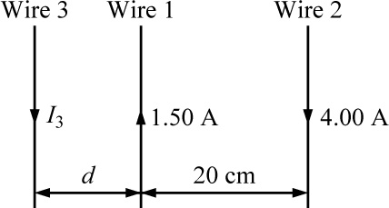

**ANS. FIG. P29.14**

(b) For the equilibrium of wire 3 we have



1.50(20.0 cm + *d*) = 4.00*d*



(a) Thus the situation is possible in just one way.

(c) For the equilibrium of wire 1,





We know that wire 2 must be in equilibrium because the forces on it are equal in magnitude to the forces that it exerts on wires 1 and 3, which are equal because they both balance the equal-magnitude forces that 1 exerts on 3 and that 3 exerts on 1.

1. The magnetic field 40.0 cm away from a long, straight wire carrying current 2.00 A is 1.00 *µ*T. (a) At what distance is it 0.100 *µ*T? (b) **What If?** At one instant, the two conductors in a long household extension cord carry equal 2.00-A currents in opposite directions. The two wires are 3.00 mm apart. Find the magnetic field 40.0 cm away from the middle of the straight cord, in the plane of the two wires. (c) At what distance is it one-tenth as large? (d) The center wire in a coaxial cable carries current 2.00 A in one direction, and the sheath around it carries current 2.00 A in the opposite direction. What magnetic field does the cable create at points outside the cable?

(a) In , the field will be one-tenth as large at a ten-times larger distance: 

(b) 

so 

(c) Call *r* the distance from cord center to field point and   
2*d* = 3.00 mm the distance between conductors.





so 

The field of the two-conductor cord is weak to start with and falls off rapidly with distance.

(d) The cable creates  field at exterior points, since a loop in Ampère’s law encloses zero total current. Shall we sell coaxial-cable power cords to people who worry about biological damage from weak magnetic fields

1. A nonconducting ring of radius 10.0 cm is uniformly charged with a total positive charge 10.0 *µ*C. The ring rotates at a constant angular speed 20.0 rad/s about an axis through its center, perpendicular to the plane of the ring. What is the magnitude of the magnetic field on the axis of the ring 5.00 cm from its center?

On the axis of a current loop, the magnetic field is given by



where in this case  The magnetic field is directed away from the center, with a magnitude of

