Chapter-24
- An insulating rod having linear charge density λ = 40.0 µC/m and linear mass density µ = 0.100 kg/m is released from rest in a uniform electric field E = 100 V/m directed perpendicular to the rod (Fig. P24.5). (a) Determine the speed of the rod after it has traveled 2.00 m. (b) What If? How does your answer to part (a) change if the electric field is not perpendicular to the rod? Explain.
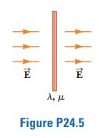

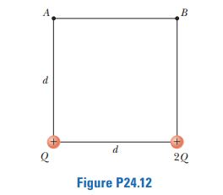
- The two charges in Figure P24.12 are separated by a distance d = 2.00 cm, and Q = +5.00 nC. Find (a) the electric potential at A, (b) the electric potential at B, and (c) the electric potential difference between B and A.

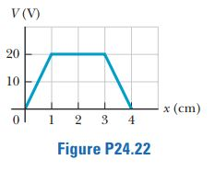
- Figure P24.22 represents a graph of the electric potential in a region of space versus position x, where the electric field is parallel to the x axis. Draw a graph of the x component of the electric field versus x in this region.

- A solid conducting sphere of radius 2.00 cm has a charge of 8.00 µC. A conducting spherical shell of inner radius 4.00 cm and outer radius 5.00 cm is concentric with the solid sphere and has a charge of -4.00 µC. Find the electric field at (a) r = 1.00 cm, (b) r = 3.00 cm, (c) r = 4.50 cm, and (d) r =7.00 cm from the center of this charge configuration

