**Chapter-22**

1. Find to three significant digits the charge and the mass of the following particles. *Suggestion:* Begin by looking up the mass of a neutral atom on the periodic table of the elements in Appendix C. (a) an ionized hydrogen atom, represented as H+ (b) a singly ionized sodium atom, Na+ (c) a chloride ion Cl- (d) a doubly ionized calcium atom, Ca++ = Ca2+ (e) the center of an ammonia molecule, modeled as an N3- ion (f) quadruply ionized nitrogen atoms, N4+, found in plasma in a hot star (g) the nucleus of a nitrogen atom (h) the molecular ion H2O.

**Ans. (a)** The charge due to loss of one electron is



The mass of an average neutral hydrogen atom is 1.007 9 u. Losing one electron reduces its mass by a negligible amount, to



(b) By similar logic, charge 



(c) Gain of one electron: charge of 



(d) Loss of two electrons: charge of  



(e) Gain of three electrons: charge of  



(f) Loss of four electrons: charge of  



(g) We think of a nitrogen nucleus as a seven-times ionized nitrogen atom. 



(h) Gain of one electron: charge 



1. Two equal positively charged particles are at opposite corners of a trapezoid as shown in Figure. Find symbolic expressions for the total electric field at (a) the point *P* and (b) the point *P’*

**Ans: (a)** See ANS. FIG. P22.17(a). The distance from the +*Q* charge on the upper left is *d*, and the distance from the +*Q* charge on the lower right to point *P* is



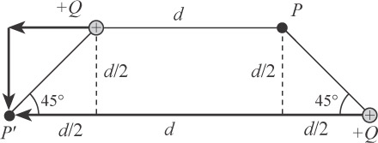 The total electric field at point *P* is then



**ANS. FIG. P22.17(b)**

(b) See ANS. FIG. P22.17(b). The distance from the +Q charge on the lower right to point P’ is 2*d*, and the distance from the +*Q* charge on the upper right to point *P*′is



The total electric field at point *P’* is then



1. A proton accelerates from rest in a uniform electric field of 640 N/C. At one later moment, its speed is 1.20 Mm/s (nonrelativistic because *v* is much less than the speed of light). (a) Find the acceleration of the proton. (b) Over what time interval does the proton reach this speed? (c) How far does it move in this time interval? (d) What is its kinetic energy at the end of this interval?

**Ans: (a)** We obtain the acceleration of the proton from the particle under a net force model, with *F* = *qE* representing the electric force:



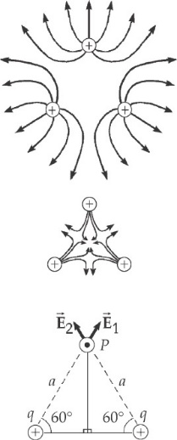 (b) The particle under constant acceleration model gives us  from which we obtain



(c) Again, from the particle under constant acceleration model,



(d) The final kinetic energy of the proton is

