Chapter-22
- Find to three significant digits the charge and the mass of the following particles. Suggestion: Begin by looking up the mass of a neutral atom on the periodic table of the elements in Appendix C. (a) an ionized hydrogen atom, represented as H⁺ (b) a singly ionized sodium atom, Na⁺ (c) a chloride ion Cl⁻ (d) a doubly ionized calcium atom, Ca⁺⁺ = Ca²⁺ (e) the center of an ammonia molecule, modeled as an N³⁻ ion (f) quadruply ionized nitrogen atoms, N⁴⁺, found in plasma in a hot star (g) the nucleus of a nitrogen atom (h) the molecular ion H₂O.

- Two equal positively charged particles are at opposite corners of a trapezoid as shown in Figure. Find symbolic expressions for the total electric field at (a) the point P and (b) the point P’

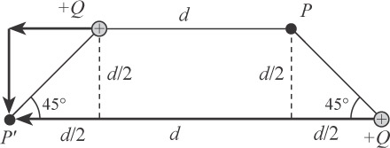

- A proton accelerates from rest in a uniform electric field of 640 N/C. At one later moment, its speed is 1.20 Mm/s (nonrelativistic because v is much less than the speed of light). (a) Find the acceleration of the proton. (b) Over what time interval does the proton reach this speed? (c) How far does it move in this time interval? (d) What is its kinetic energy at the end of this interval?

