Chapter-19

- The highest waterfall in the world is the Salto Angel in Venezuela. Its longest single falls has a height of 807 m. If water at the top of the falls is at 15.08C, what is the maximum temperature of the water at the bottom of the falls? Assume all the kinetic energy of the water as it reaches the bottom goes into raising its temperature.
Solution:

- You are working in your kitchen preparing lunch for your family. You have decided to make egg salad sandwiches and are boiling six eggs, each of mass 55.5 g, in 0.750 L of water at 100ºC. You wish to take all the eggs out of the boiling water and immediately place them in 23.0ºC water to cool them down to a comfortable temperature to hold them and peel them. You decide that you wish the mixture of the water and the eggs to reach an equilibrium temperature of 40.0ºC. Explaining this to a family member, she challenges you to determine exactly how much water at 23.0ºC you need to achieve your desired equilibrium temperature. Take the average specific heat of an egg over the expected temperature range to be 3.27 x 10³ J/kg . ºC
Solution:

- How much energy is required to change a 40.0-g ice cube from ice at -10.0ºC to steam at 110ºC?
Solution:

- (a) Determine the work done on a gas that expands from i to f as indicated in Figure P19.16. (b) What If? How much work is done on the gas if it is compressed from f to i along the same path?
Solution:
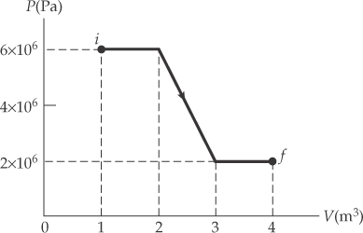

- A 2.00-mol sample of helium gas initially at 300 K, and 0.400 atm is compressed isothermally to 1.20 atm. Noting that the helium behaves as an ideal gas, find (a) the final volume of the gas, (b) the work done on the gas, and (c) the energy transferred by heat
Solution:

