**Chapter – 16**

**1. A sinusoidal wave traveling in the negative x direction (to the left) has an amplitude of 20.0 cm, a wavelength of 35.0 cm, and a frequency of 12.0 Hz. The transverse position of an element of the medium at t = 0, x = 0 is y = -3.00 cm, and the element has a positive velocity here. We wish to find an expression for the wave function describing this wave. (a) Sketch the wave at t = 0. (b) Find the angular wave number k from the wavelength. (c) Find the period T from the frequency. Find (d) the angular frequency ω and (e) the wave speed v. (f) From the information about t = 0, find the phase constant ϕ (g) Write an expression for the wave function y(x, t)**

**Solution:**

(a) ANS. FIG. P16.8 (a) shows a sketch of the wave at *t* = 0.

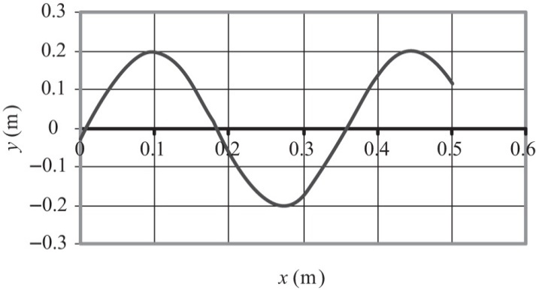

(b) 

(c) 

(d) 

(e) 

(f)  specializes to



(g) At x = 0, t = 0 we require



so 

**2. A seismographic station receives S and P waves from an earthquake, separated in time by 17.3 s. Assume the waves have traveled over the same path at speeds of 4.50 km/s and 7.80 km/s. Find the distance from the seismograph to the focus of the quake.**

**Solution:**

The distance the waves have traveled is *d* = (7.80 km/s)*t* =   
(4.50 km/s)(*t* + 17.3 s), where *t* is the travel time for the faster wave.

Then, 

or 

and the distance is 

**3*.Why is the following situation impossible?* At the Summer Olympics, an athlete runs at a constant speed down a straight track while a spectator near the edge of the track blows a note on a horn with a fixed frequency. When the athlete passes the horn, she hears the frequency of the horn fall by the musical interval called a minor third. That is, the frequency she hears drops to five-sixths its original value.**

**Solution:**

The apparent frequency drops because of the Doppler effect. Using a *T* subscript for the situation when the athlete moves *toward* the horn, and *A* for movement away from the horn, we have,



where *v*0 is the constant speed of the athlete. Setting this ratio equal to 5/6, we have

 Solving for the speed of the athlete,

 

**4. A sound wave propagates in air at 27oC with frequency 4.00 kHz. It passes through a region where the temperature gradually changes and then moves through air at 0oC. Give numerical answers to the following questions to the extent possible and state your reasoning about what happens to the wave physically. (a) What happens to the speed of the wave? (b) What happens to its frequency? (c) What happens to its wavelength?**

**Solution:**

(a) 

(b) 

(c) 