Chapter-13

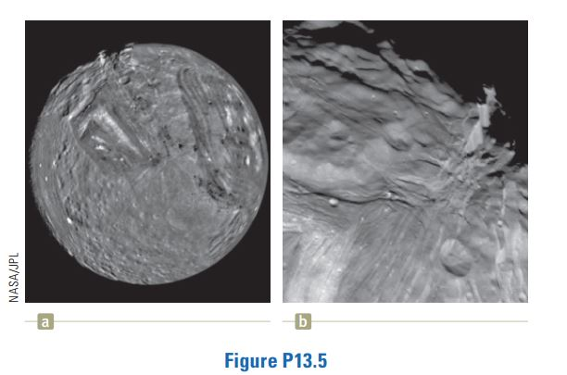
- Miranda, a satellite of Uranus, is shown in Figure P13.5a. It can be modeled as a sphere of radius 242 km and mass 6.68 x 10¹⁹ kg. (a) Find the free-fall acceleration on its surface. (b) A cliff on Miranda is 5.00 km high. It appears on the limb at the 11 o’clock position in Figure P13.5a and is magnified in Figure P13.5b. If a devotee of extreme sports runs horizontally off the top of the cliff at 8.50 m/s, for what time interval is he in flight? (c) How far from the base of the vertical cliff does he strike the icy surface of Miranda? (d) What will be his vector impact velocity?
Solution:

- A spacecraft in the shape of a long cylinder has a length of 100 m, and its mass with occupants is 1 000 kg. It has strayed too close to a black hole having a mass 100 times that of the Sun (Fig. P13.7). The nose of the spacecraft points toward the black hole, and the distance between the nose and the center of the black hole is 10.0 km. (a) Determine the total force on the spacecraft. (b) What is the difference in the gravitational fields acting on the occupants in the nose of the ship and on those in the rear of the ship, farthest from the black hole? (This difference in accelerations grows rapidly as the ship approaches the black hole. It puts the body of the ship under extreme tension and eventually tears it apart.)

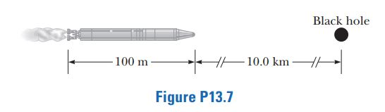

Solution:

- An asteroid is on a collision course with Earth. An astronaut lands on the rock to bury explosive charges that will blow the asteroid apart. Most of the small fragments will miss the Earth, and those that fall into the atmosphere will produce only a beautiful meteor shower. The astronaut finds that the density of the spherical asteroid is equal to the average density of the Earth. To ensure its pulverization, she incorporates
into the explosives the rocket fuel and oxidizer intended for her return journey. What maximum radius can the asteroid have for her to be able to leave it entirely simply by jumping straight up? On Earth she can jump to a height of 0.500 m.
Solution:

Chapter-14

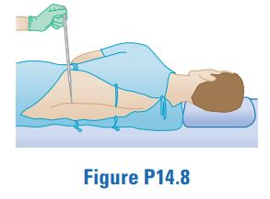
- The human brain and spinal cord are immersed in the cerebrospinal fluid. The fluid is normally continuous between the cranial and spinal cavities and exerts a pressure of 100 to 200 mm of H₂O above the prevailing atmospheric pressure. In medical work, pressures are often measured in units of millimeters of H₂O because body fluids, including the cerebrospinal fluid, typically have the same density as water. The pressure of the cerebrospinal fluid can be measured by means of a spinal tap as illustrated in Figure P14.8. A hollow tube is inserted into the spinal column, and the height to which the fluid rises is observed. If the fluid rises to a height of 160 mm, we write its gauge pressure as 160 mm H₂O. (a) Express this pressure in pascals, in atmospheres, and in millimeters of mercury. (b) Some conditions that block or inhibit the flow of cerebrospinal fluid can be investigated by means of Queckenstedt’s test. In this procedure, the veins in the patient’s neck are compressed to make the blood pressure rise in the brain, which in turn should be transmitted to the cerebrospinal fluid. Explain how the level of fluid in the spinal tap can be used as a diagnostic tool for the condition of the patient’s spine.
Solution:

- On October 21, 2001, Ian Ashpole of the United Kingdom achieved a record altitude of 3.35 km (11 000 ft) powered by 600 toy balloons filled with helium. Each filled balloon had a radius of about 0.50 m and an estimated mass of 0.30 kg. (a) Estimate the total buoyant force on the 600 balloons. (b) Estimate the net upward force on all 600 balloons. (c) Ashpole parachuted to the Earth after the balloons began to burst at the high altitude and the buoyant force decreased. Why did the balloons burst?
Solution:

- Water is pumped up from the Colorado River to supply Grand Canyon Village, located on the rim of the canyon. The river is at an elevation of 564 m, and the village is at an elevation of 2 096 m. Imagine that the water is pumped through a single long pipe 15.0 cm in diameter, driven by a single pump at the bottom end. (a) What is the minimum pressure at which the water must be pumped if it is to arrive at the village? (b) If 4 500 m³ of water is pumped per day, what is the speed of the water in the pipe? Note: Assume the free-fall acceleration and the density of air are constant over this range of elevations. The pressures you calculate are too high for an ordinary pipe. The water is actually lifted in stages by several pumps through shorter pipes.
Solution:

Chapter-15

- The amplitude of a system moving in simple harmonic motion is doubled. Determine the change in (a) the total energy, (b) the maximum speed, (c) the maximum acceleration, and (d) the period.
Solution:

- A 2.00-kg object attached to a spring moves without friction (b= 0) and is driven by an external force given by the expression F = 3.00 sin (2pt), where F is in newtons and t is in seconds. The force constant of the spring is 20.0 N/m. Find (a) the resonance angular frequency of the system, (b) the angular frequency of the driven system, and (c) the amplitude of the motion.
Solution:

