Chapter - 10

- A wheel starts from rest and rotates with constant angular acceleration to reach an angular speed of 12.0 rad/s in 3.00 s. Find (a) the magnitude of the angular acceleration of the wheel and (b) the angle in radians through which it rotates in this time interval.
Solution:

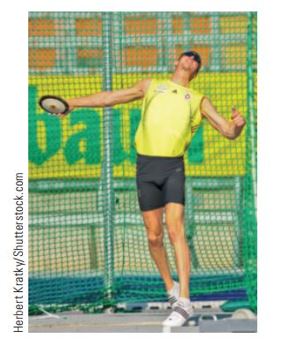
- A discus thrower (Fig. P10.9) accelerates a discus from rest to a speed of 25.0 m/s by whirling it through 1.25 rev. Assume the discus moves on the arc of a circle 1.00 m in radius. (a) Calculate the final angular speed of the discus. (b) Determine the magnitude of the angular acceleration of the discus, assuming it to be constant. (c) Calculate the time interval required for the discus to accelerate from rest to 25.0 m/s
Solution:

- A model airplane with mass 0.750 kg is tethered to the ground by a wire so that it flies in a horizontal circle 30.0 m in radius. The airplane engine provides a net thrust of 0.800 N perpendicular to the tethering wire. (a) Find the torque the net thrust produces about the center of the circle. (b) Find the angular acceleration of the airplane. (c) Find the translational acceleration of the airplane tangent to its flight path.
Solution:

- Rigid rods of negligible mass lying along the y axis connect three particles (Fig. P10.25). The system rotates about the x axis with an angular speed of 2.00 rad/s. Find (a) the moment of inertia about the x axis, (b) the
total rotational kinetic energy evaluated from 1/2 Iω², (c) the tangential speed of each particle, and (d) the total kinetic energy evaluated from Σ1/2 m_{i}v_{i}². (e) Compare the answers for kinetic energy in parts (a) and (b)
Solution:

Chapter 11

- A uniform solid sphere of radius r = 0.500 m and mass m = 15.0 kg turns counterclockwise about a vertical axis through its centre. Find its vector angular momentum about this axis when its angular speed is 3.00 rad/s.
Solution:

- A 60.0-kg woman stands at the western rim of a horizontal turntable having a moment of inertia of 500 kg . m² and a radius of 2.00 m. The turntable is initially at rest and is free to rotate about a frictionless, vertical axle through its center. The woman then starts walking around the rim clockwise (as viewed from above the system) at a constant speed of 1.50 m/s relative to the Earth. Consider the woman–turntable system as motion begins. (a) Is the mechanical energy of the system constant? (b) Is the momentum of the system constant? (c) Is the angular momentum of the system constant? (d) In what direction and with what angular speed does the turntable rotate? (e) How much potential energy in the woman’s body is converted into mechanical energy of the woman–turntable system as the woman sets herself and the turntable into motion?
Solution:

- The angular momentum vector of a precessing gyroscope sweeps out a cone as shown in Figure P11.31. The angular speed of the tip of the angular momentum vector, called its precessional frequency, is given by ω_{p}=τ/L, where τ is the magnitude of the torque on the gyroscope and L is the magnitude of its angular momentum. In the motion called precession of the equinoxes, the Earth’s axis of rotation precesses about the perpendicular to its orbital plane with a period of 2.58X10⁴ yr. Model the Earth as a uniform sphere and calculate the torque on the Earth that is causing this precession.
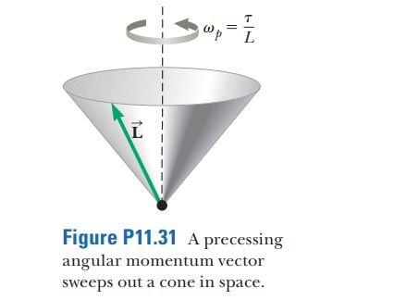

Solution:

