**Chapter-34**

1. Find the speed of light in (a) flint glass, (b) water, and (c) cubic zirconia.

(a) flint glass: 

(b) water: 

(c) cubic zirconia: 

1. A plane sound wave in air at 20°C, with wavelength 589 mm, is incident on a smooth surface of water at 25°C at an angle of incidence of 13.0°. Determine (a) the angle of refraction for the sound wave and (b) the wavelength of the sound in water. A narrow beam of sodium yellow light, with wavelength 589 nm in vacuum, is incident from air onto a smooth water surface at an angle of incidence of 13.0°. Determine (c) the angle of refraction and (d) the wavelength of the light in water. (e) Compare and contrast the behavior of the sound and light waves in this problem.

(a) The law of refraction    
can be put into the more general form



This is equivalent to Equation 34.2. This form applies to all kinds of waves that move through space.

In air at 20°C, the speed of sound is 343 m/s. From Table 17.1, the speed of sound in water at 25.0°C is 1493 m/s. The angle of incidence is 13.0°:



(b) The wave keeps constant frequency in all media:



(c) Using Snell’s law,



(d) 

(e) 

1. Consider a light ray traveling between air and a diamond cut in the shape shown in Figure P34.28. (a) Find the critical angle for total internal reflection for light in the diamond incident on the interface between the diamond and the outside air. (b) Consider the light ray incident normally on the top surface of the diamond as shown in Figure P34.28. Show that the light traveling toward point *P* in the diamond is totally reflected. **What If?** Suppose the diamond is immersed in water. (c) What is the critical angle at the diamond–water interface? (d) When the diamond is immersed in water, does the light ray entering the top surface in Figure P34.28 undergo total internal reflection at *P*? Explain. (e) If the light ray entering the diamond remains vertical as shown in Figure P34.28, which way should the diamond in the water be rotated about an axis perpendicular to the page through *O* so that light will exit the diamond at *P*? (f) At what angle of rotation in part (e) will light first exit the diamond at point *P*?

(a) Using the index of refraction values listed in Table 34.1, we find

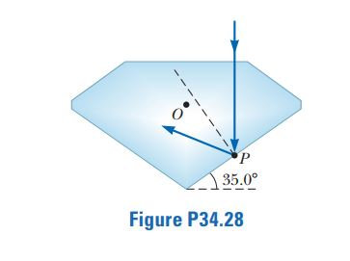 

(b) 

(c) 

(d) The angle of incidence is 34.0°. Yes. In this case, the angle of incidence is just larger than the critical angle, so the light ray again undergoes total internal reflection at *P*.

(e) The angle of incidence must be reduced below the critical angle for light to exit the diamond, so the diamond should be rotated clockwise.

(f) Rotating the diamond by angle *θ* clockwise changes the angle of incidence  at point *A* from 0.00° to *θ*, causing the angle of refraction  inside the diamond to change from 0.00°:



Refer to ANS. FIG. P34.28. What is the angle of incidence at *P*?

Extending a line from points *A* and *P* parallel to the surfaces of the diamond until they meet at point *B*, we form a triangle *ABP*.

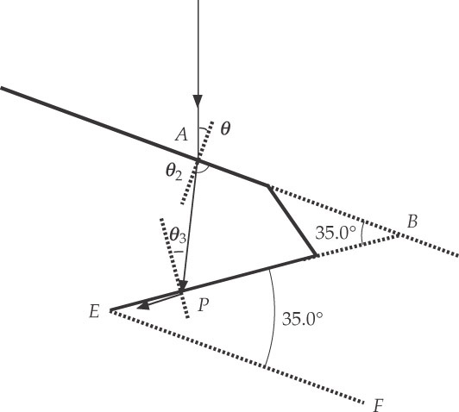

**ANS. FIG. P34.28**

The angle at vertex *B* is 34.0° because the extended line *AB* is parallel to the line *EF* extended from the base of the diamond. From the sum of the interior angles of *ABP*, we find the incident angle  at point *P*:



At *P*, we require that the angle of incidence  results in an angle of refraction of 90.0°:



solving gives  Then, from above,

