Chapter-34
- Find the speed of light in (a) flint glass, (b) water, and (c) cubic zirconia.

- A plane sound wave in air at 20°C, with wavelength 589 mm, is incident on a smooth surface of water at 25°C at an angle of incidence of 13.0°. Determine (a) the angle of refraction for the sound wave and (b) the wavelength of the sound in water. A narrow beam of sodium yellow light, with wavelength 589 nm in vacuum, is incident from air onto a smooth water surface at an angle of incidence of 13.0°. Determine (c) the angle of refraction and (d) the wavelength of the light in water. (e) Compare and contrast the behavior of the sound and light waves in this problem.

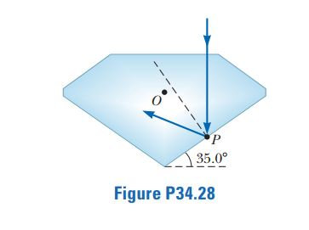
- Consider a light ray traveling between air and a diamond cut in the shape shown in Figure P34.28. (a) Find the critical angle for total internal reflection for light in the diamond incident on the interface between the diamond and the outside air. (b) Consider the light ray incident normally on the top surface of the diamond as shown in Figure P34.28. Show that the light traveling toward point P in the diamond is totally reflected. What If? Suppose the diamond is immersed in water. (c) What is the critical angle at the diamond–water interface? (d) When the diamond is immersed in water, does the light ray entering the top surface in Figure P34.28 undergo total internal reflection at P? Explain. (e) If the light ray entering the diamond remains vertical as shown in Figure P34.28, which way should the diamond in the water be rotated about an axis perpendicular to the page through O so that light will exit the diamond at P? (f) At what angle of rotation in part (e) will light first exit the diamond at point P?

