Chapter-32
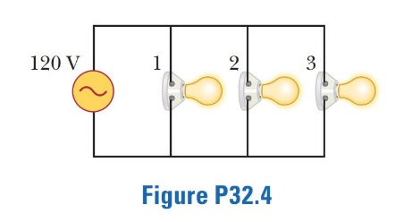
- Figure P32.4 shows three lightbulbs connected to a 120-V AC (rms) household supply voltage. Bulbs 1 and 2 have a power rating of 150 W, and bulb 3 has a 100-W rating. Find (a) the rms current in each bulb and (b) the resistance of each bulb. (c) What is the total resistance of the combination of the three lightbulbs?

- An AC source with ΔV _{max} = 150 V and f = 50.0 Hz is connected between points a and d in Figure P32.16. Calculate the maximum voltages between (a) points a and b, (b) points b and c, (c) points c and d, and (d) points b and d
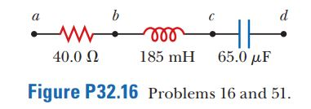

- A 60.0-Ω resistor is connected in series with a 30.0-µF capacitor and a source whose maximum voltage is 120 V, operating at 60.0 Hz. Find (a) the capacitive reactance of the circuit, (b) the impedance of the circuit, and (c) the maximum current in the circuit. (d) Does the voltage lead or lag the current? (e) How will adding an inductor in series with the existing resistor and capacitor affect the current? Explain

- A series RLC circuit has components with the following values: L = 20.0 mH, C = 100 nF, R = 20.0 Ω, and ΔV _{max} = 100 V, with Δν = ΔV _{max} sin ωt. Find (a) the resonant frequency of the circuit, (b) the amplitude of the current at the resonant frequency, (c) the Q of the circuit, and (d) the amplitude of the voltage across the inductor at resonance.

