**Chapter-27**

1. A lightbulb marked “75 W [at] 120 V” is screwed into a socket at one end of a long extension cord, in which each of the two conductors has resistance 0.800 Ω. The other end of the extension cord is plugged into a 120-V outlet. (a) Explain why the actual power delivered to the lightbulb cannot be 75 W in this situation. (b) Draw a circuit diagram. (c) Find the actual power delivered to the lightbulb in this circuit.

(a) 

(b) See the circuit diagram in ANS7. FIG. P27.4; the 192-Ω resistor is the lightbulb (see below).

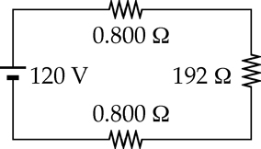

**ANS. FIG. P27.4**

(c) First, find the operating resistance of the lightbulb:



or 

From the circuit, the total resistance is 193.6 Ω. The current is



so the power delivered to the lightbulb is



1. Calculate the power delivered to each resistor in the circuit shown in Figure P27.13.

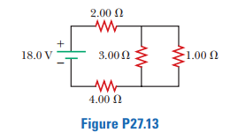

To find the current in each resistor, we find the resistance seen by the battery. The given circuit reduces as shown in ANS. FIG. P27.13 (a), since



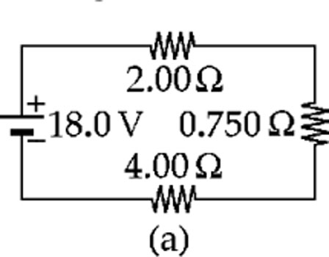

In ANS. FIG. P27.13 (b),

*I* = 18.0 V/6.75 Ω = 2.67 A

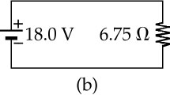 This is also the current in ANS. FIG. P27.13 (a), so  
 the 2.00-Ω and 4.00-Ω resistors convert powers

**ANS. FIG. P27.13**

**

and **

The voltage across the 0.750-Ω resistor in   
ANS. FIG. P27.13 (a), and across both the 3.00-Ω   
and the 1.00-Ω resistors in Figure P27.13, is

**

Then for the 3.00-Ω resistor,



and the power is



For the 1.00-Ω resistor,



1. The following equations describe an electric circuit:  
   -*I*1 (220 Ω) + 5.80 V - *I*2 (370 Ω) = 0  
   +*I*2 (370 Ω) + *I*3 (150 Ω) - 3.10 V 5 0  
   *I*1 + *I*3- *I*2 = 0  
   (a) Draw a diagram of the circuit. (b) Calculate the unknowns and identify the physical meaning of each unknown.

(a) The first equation represents Kirchhoff’s loop theorem. We choose to think of it as describing a clockwise trip around the left-hand loop in a circuit; see ANS. FIG. P27.18(a).

For the right-hand loop see ANS. FIG. P28.18(b). The junctions must be between the 5.80-V emf and the 370-Ω resistor and between the 370-Ω resistor and the 150-Ω resistor. Then we have ANS. FIG. P28.18(c). This is consistent with the third equation,

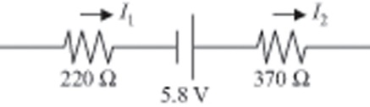

**ANS. FIG. P27.18(a)**



(b) Suppressing units, we substitute:

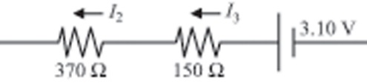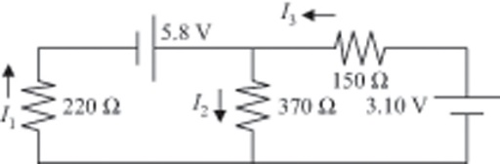

**ANS. FIG. P27.18(b)**

**ANS. FIG. P27.18(c)**



Next , 

