Chapter-27
- A lightbulb marked “75 W [at] 120 V” is screwed into a socket at one end of a long extension cord, in which each of the two conductors has resistance 0.800 Ω. The other end of the extension cord is plugged into a 120-V outlet. (a) Explain why the actual power delivered to the lightbulb cannot be 75 W in this situation. (b) Draw a circuit diagram. (c) Find the actual power delivered to the lightbulb in this circuit.

- Calculate the power delivered to each resistor in the circuit shown in Figure P27.13.
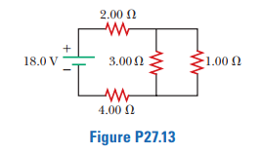
To find the current in each resistor, we find the resistance seen by the battery. The given circuit reduces as shown in ANS. FIG. P27.13 (a), since

- The following equations describe an electric circuit:
-I ₁ (220 Ω) + 5.80 V - I₂ (370 Ω) = 0
+I₂ (370 Ω) + I₃ (150 Ω) - 3.10 V 5 0
I₁ + I₃- I₂ = 0
(a) Draw a diagram of the circuit. (b) Calculate the unknowns and identify the physical meaning of each unknown.

