**Chapter-25**

1. Two capacitors give an equivalent capacitance of 9.00 pF when connected in parallel and an equivalent capacitance of 2.00 pF when connected in series. What is the capacitance of each capacitor?

Cp = C1 + C2 and Substitute C2 = Cp− C1:



Simplifying,





We choose arbitrarily the + sign. (This choice can be arbitrary, since with the case of the minus sign, we would get the same two answers with their names interchanged.)

1. Two identical parallel-plate capacitors, each with capacitance 10.0 µF, are charged to potential difference 50.0 V and then disconnected from the battery. They are then connected to each other in parallel with plates of like sign connected. Finally, the plate separation in one of the capacitors is doubled. (a) Find the total energy of the system of two capacitors before the plate separation is doubled. (b) Find the potential difference across each capacitor after the plate separation is doubled. (c) Find the total energy of the system after the plate separation is doubled. (d) Reconcile the difference in the answers to parts (a) and (c) with the law of conservation of energy.

Ans: (a) Because the capacitors are connected in parallel, their voltage remains the same:



(b) Because  and *d* → 2*d*, the altered capacitor has new capacitance to . The total charge is the same as before:



(c) New 



(d) 

1. Two capacitors, C1 = 25.0 µF and C2 = 5.00 µF, are connected in parallel and charged with a 100-V power supply. (a) Draw a circuit diagram and (b) calculate the total energy stored in the two capacitors. (c) What If? What potential difference would be required across the same two capacitors connected in series for the combination to store the same amount of energy as in part (b)? (d) Draw a circuit diagram of the circuit described in part (c)

(a) The circuit diagram for capacitors connected in parallel is shown in ANS. FIG. P25.21(a).

(b) 

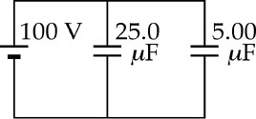

**ANS. FIG. P25.21(a)**

an



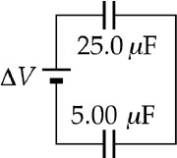 (c) 



(d) The circuit diagram for capacitors connected in series is shown in ANS. FIG. P25.21(d).