**Chapter-21**

1. **During each cycle, a refrigerator ejects 625 kJ of energy to a high-temperature reservoir and takes in 550 kJ of energy from a low-temperature reservoir. Determine (a) the work done on the refrigerant in each cycle and (b) the coefficient of performance of the refrigerator.**

**Solution**

1. The work done on the refrigerant in each cycle is



(b) The coefficient of performance of a refrigerator is:



Solving numerically:



1. **One of the most efficient heat engines ever built is a coal-fired steam turbine in the Ohio River valley, operating between 1 870°C and 430°C. (a) What is its maximum theoretical efficiency? (b) The actual efficiency of the engine is 42.0%. How much mechanical power does the engine deliver if it absorbs 1.40 x 105 J of energy each second from its hot reservoir?**

**Solution**

We use the Carnot expression for maximum possible efficiency, and the definition of efficiency to find the useful output. The engine is a steam turbine in an electric generating station with



(a) 

(b) 

for one second of operation, so



and the power is



**3. A gasoline engine has a compression ratio of 6.00. (a) What is the efficiency of the engine if it operates in an idealized Otto cycle? (b) What If? If the actual efficiency is 15.0%, what fraction of the fuel is wasted as a result of friction and energy transfers by heat that could be avoided in a reversible engine? Assume complete combustion of the air–fuel mixture.**

**Solution**

Compression ratio = 6.00, *γ* = 1.40

(a) Efficiency of an Otto engine: 



(b) If actual efficiency *e’* = 15.0%, the fraction of fuel wasted is (assuming complete combustion of the air-fuel mixture) .

**Chapter-22**

1. **(a) Find the magnitude of the electric force between a Na+ ion and a Cl- ion separated by 0.50 nm. (b) Would the answer change if the sodium ion were replaced by Li+ and the chloride ion by Br-? Explain.**

**Solution:**

(a) The two ions are both singly charged, , one positive and one negative. Thus,



1. No. The electric force depends only on the magnitudes of the two charges and the distance between them.

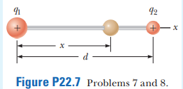**2. Two small beads having positive charges q1 = 3q and q2 = q are fixed at the opposite ends of a horizontal insulating rod of length d = 1.50 m. The bead with charge q1 is at the origin. As shown in Figure P22.7, a third small, charged bead is free to slide on the rod. (a) At what position x is the third bead in equilibrium? (b) Can the equilibrium be stable?**

**Solution**

(a) Let the third bead have charge *Q* and be located distance *x* from the left end of the rod. This bead will experience a net force given by

, where *d* = 1.50 m

The net force will be zero if , or .

This gives an equilibrium position of the third bead of

*x* = 0.634*d* = 0.634(1.50 m) = 

(b)  The equilibrium would be stable because if charge *Q* were displaced either to the left or right on the rod, the new net force would be opposite to the direction *Q* has been displaced, causing it to be pushed back to its equilibrium position.

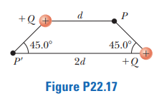

1. **Two equal positively charged particles are at opposite corners of a trapezoid as shown in Figure P22.17. Find symbolic expressions for the total electric field at (a) the point P and (b) the point P’.**

**Solution**

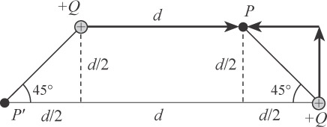(a) See ANS. FIG. P22.17(a). The distance from the +*Q* charge on the upper left is *d*, and the distance from the +*Q* charge on the lower right to point *P* is



The total electric field at point *P* is then



(b) See ANS. FIG. P22.17(b). The distance from the +Q charge on the lower right to point P’ is 2*d*, and the distance from the +*Q* charge on the upper right to point *P*′is

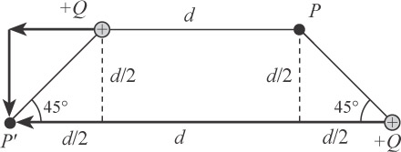

**ANS. FIG. P22.17(b)**



The total electric field at point *P’* is then

