Chapter-21

- During each cycle, a refrigerator ejects 625 kJ of energy to a high-temperature reservoir and takes in 550 kJ of energy from a low-temperature reservoir. Determine (a) the work done on the refrigerant in each cycle and (b) the coefficient of performance of the refrigerator.
Solution:

- One of the most efficient heat engines ever built is a coal-fired steam turbine in the Ohio River valley, operating between 1 870°C and 430°C. (a) What is its maximum theoretical efficiency? (b) The actual efficiency of the engine is 42.0%. How much mechanical power does the engine deliver if it absorbs 1.40 x 10⁵ J of energy each second from its hot reservoir?
Solution:

3. A gasoline engine has a compression ratio of 6.00. (a) What is the efficiency of the engine if it operates in an idealized Otto cycle? (b) What If? If the actual efficiency is 15.0%, what fraction of the fuel is wasted as a result of friction and energy transfers by heat that could be avoided in a reversible engine? Assume complete combustion of the air–fuel mixture.
Solution:

Chapter-22

- (a) Find the magnitude of the electric force between a Na⁺ ion and a Cl⁻ ion separated by 0.50 nm. (b) Would the answer change if the sodium ion were replaced by Li⁺ and the chloride ion by Br⁻? Explain.
Solution:

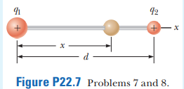
2. Two small beads having positive charges q₁ = 3q and q₂ = q are fixed at the opposite ends of a horizontal insulating rod of length d = 1.50 m. The bead with charge q₁ is at the origin. As shown in Figure P22.7, a third small, charged bead is free to slide on the rod. (a) At what position x is the third bead in equilibrium? (b) Can the equilibrium be stable?
Solution:

3. Two equal positively charged particles are at opposite corners of a trapezoid as shown in Figure P22.17. Find symbolic expressions for the total electric field at (a) the point P and (b) the point P’.
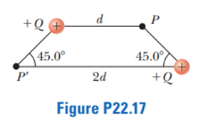
Solution

