**Chapter-19**

1. **The highest waterfall in the world is the Salto Angel in Venezuela. Its longest single falls has a height of 807 m. If water at the top of the falls is at 15.08C, what is the maximum temperature of the water at the bottom of the falls? Assume all the kinetic energy of the water as it reaches the bottom goes into raising its temperature.**

**Solution:**

As mass *m* of water drops from top to bottom of the falls, the gravitational potential energy given up (and hence, the kinetic energy gained) is *Q* = *mgh*. If all of this goes into raising the temperature,   
** and the rise in temperature will be



and the final temperature is



1. **You are working in your kitchen preparing lunch for your family. You have decided to make egg salad sandwiches and are boiling six eggs, each of mass 55.5 g, in 0.750 L of water at 100oC. You wish to take all the eggs out of the boiling water and immediately place them in 23.0oC water to cool them down to a comfortable temperature to hold them and peel them. You decide that you wish the mixture of the water and the eggs to reach an equilibrium temperature of 40.0oC. Explaining this to a family member, she challenges you to determine exactly how much water at 23.0oC you need to achieve your desired equilibrium temperature. Take the average specific heat of an egg over the expected temperature range to be 3.27 x 103 J/kg . oC**

**Solution:**

**Conceptualize** When the eggs are cooking, they are in boiling water, so their temperature is 100°C. They are then transferred to 23.0°C water, and the combination of eggs and water reaches an equilibrium temperature of 40.0°C.

**Categorize** This is a calorimetry problem: you are mixing hot eggs and cool water.

**Analyze** We use Equation 19.5:

 (1)

Substitute for each side of the equation, water on the left, eggs on the right:

 (2)

Solve for the required mass of water:

 (3)

Substitute numerical values:



**Finalize** The mass of water that we found corresponds to a volume of about a liter of water, or, in common U.S. kitchen measurements, close to a quart.

*Answer:* 0.918 kg

1. **How much energy is required to change a 40.0-g ice cube from ice at -10.0oC to steam at 110oC?**

**Solution:**

The energy input needed is the sum of the following terms:



Thus, we have



1. **(a) Determine the work done on a gas that expands from i to f as indicated in Figure P19.16. (b) What If? How much work is done on the gas if it is compressed from f to i along the same path?**

**Solution:**

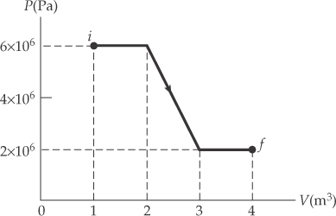 (a) 



(b) 

1. **A 2.00-mol sample of helium gas initially at 300 K, and 0.400 atm is compressed isothermally to 1.20 atm. Noting that the helium behaves as an ideal gas, find (a) the final volume of the gas, (b) the work done on the gas, and (c) the energy transferred by heat**

**Solution:**

(a) Rearranging *PV* = *nRT* we get 

The initial volume is



For isothermal compression, *PV* is constant, so *PiVi* = *PfVf*  and the final volume is



(b) 

(c) The ideal gas keeps constant temperature so  and the heat is 