**Chapter - 1**

1. **What mass of a material with density ρ is required to make a hollow spherical shell having inner radius r1 and outer radius r2?**

Solution:

The volume of a spherical shell can be calculated from



From the definition of density, , so



1. **The position of a particle moving under uniform acceleration is some function of time and the acceleration. Suppose we write this position as x = kamtn, where k is a dimensionless constant. Show by dimensional analysis that this expression is satisfied if m=1 and n=2. Can this analysis give the value of k?**

Solution:

The term *x* has dimensions of L, *a* has dimensions of  and *t* has dimensions of T. Therefore, the equation has dimensions of



The powers of L and T must be the same on each side of the equation. Therefore,

 and 

Likewise, equating terms in T, we see that *n* – 2*m* must equal 0. Thus, . The value of *k*, a dimensionless constant, .

**Chapter - 2**

1. **A person takes a trip, driving with a constant speed of 89.5 km/h, except for a 22.0-min rest stop. If the person’s average speed is 77.8 km/h, (a) how much time is spent on the trip and (b) how far does the person travel?**

Solution:

(a) The total time for the trip is *t*total = *t*1 + 22.0 min = *t*1 + 0.367 h, where *t*1 is the time spent traveling at *v*1 = 89.5 km/h. Thus, the distance traveled is  which gives



or 

from which, *t*1= 2.44 h, for a total time of



(b) The distance traveled during the trip is  giving



1. **An electron in a cathode-ray tube accelerates uniformly from 2.00 × 104 m/s to 6.00 × 106 m/s over 1.50 cm. (a) In what time interval does the electron travel this 1.50 cm? (b) What is its acceleration?**

Solution:

We have   and 

(a) 



(b) :



**Chapter - 3**

1. 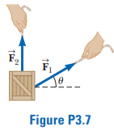**A force** **of magnitude 6.00 units acts on an object at the origin in a direction *Ɵ* = 30.0° above the positive x axis (Fig. P3.7). A second force**  **of magnitude 5.00 units acts on the object in the direction of the positive y axis. Find graphically the magnitude and direction of the resultant force** .

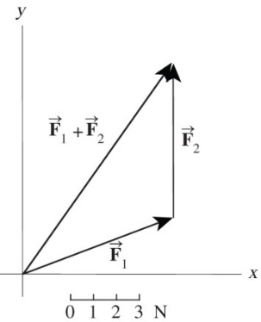Solution:

We find the resultant  graphically by placing the tail of  at the head of . The resultant force vector  is of magnitude  and at an angle of 

1. **Given the displacement vectors $\vec{A}$ = (3î - 4ĵ + 4k̂) m and $\vec{B}$ = (2î + 3ĵ - 7k̂) m, find the magnitudes of the following vectors and express each in terms of its rectangular components. (a) $\vec{C}=\vec{A}+\vec{B}$ (b) $\vec{D}=2\vec{A}-\vec{B}$**

Solution

We carry out the prescribed mathematical operations using unit vectors.

(a) 

(b) 

**Chapter - 4**

1. **A projectile is fired in such a way that its horizontal range is equal to three times its maximum height. What is the angle of projection?**

Solution:

We ignore the trivial case where the angle of projection equals zero degrees.



so 

or 

thus, 

1. **The pilot of an airplane notes that the compass indicates a heading due west. The airplane’s speed relative to the air is 150 km/h. The air is moving in a wind at 30.0 km/h toward the north. Find the velocity of the airplane relative to the ground.**

Solution:

The westward speed of the airplane is the horizontal component of its velocity vector, and the northward speed of the wind is the vertical component of its velocity vector, which has magnitude and direction given by





**Chapter - 5**

1. **A 3.00-kg object undergoes an acceleration given by**  **Find (a) the resultant force acting on the object and (b) the magnitude of the resultant force.**

Solution:

We use Newton’s second law to find the force as a vector and then the Pythagorean theorem to find its magnitude. The givens are *m* = 3.00 kg and 

(a) The total vector force is



(b) Its magnitude is



1. **If a man weighs 900 N on the Earth, what would he weigh on Jupiter, where the free-fall acceleration is 25.9 m/s2?**

Solution:

We are given, from which we can find the man’s mass,



Then, his weight on Jupiter is given by



**Chapter - 6**

1. **In the Bohr model of the hydrogen atom, an electron moves in a circular path around a proton. The speed of the electron is approximately 2.20 × 106 m/s. Find (a) the force acting on the electron as it revolves in a circular orbit of radius 0.529 × 10-10 m and (b) the centripetal acceleration of the electron.**

Solution:

1. The force acting on the electron in the Bohr model of the hydrogen atom is directed radially inward and is equal to



(b)



1. **A hawk flies in a horizontal arc of radius 12.0 m at constant speed 4.00 m/s. (a) Find its centripetal acceleration. (b) It continues to fly along the same horizontal arc, but increases its speed at the rate of 1.20 m/s2. Find the acceleration (magnitude and direction) in this situation at the moment the hawk’s speed is 4.00 m/s.**

Solution:

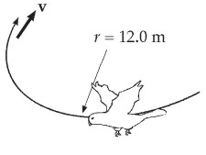(a) The hawk’s centripetal acceleration is



(b) The magnitude of the acceleration vector is

**ANS. FIG. P6.9**



at an angle

