

Department of Physics, National Dong Hwa University,

No. 1, Sec. 2, Da Hsueh Rd., Shoufeng, Hualien, 97401, Taiwan

**General Physics-I (PHYS1000AA, AB, AC)**

**Quiz - 3**

Date: 2021-12-23 Fall Semester-110

Time: 11:00 am – 11:20 am Maximum marks: 100

Student id: Name:

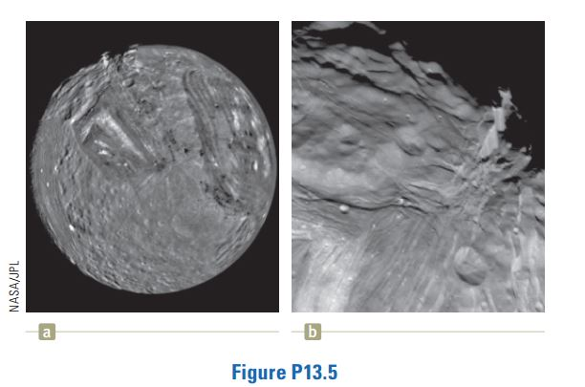**1. Miranda, a satellite of Uranus, is shown in Figure P13.5a. It can be modeled as a sphere of radius 242 km and mass 6.68 x 1019 kg. (a) Find the free-fall acceleration on its surface. (b) A cliff on Miranda is 5.00 km high. It appears on the limb at the 11 o’clock position in Figure P13.5a and is magnified in Figure P13.5b. If a devotee of extreme sports runs horizontally off the top of the cliff at 8.50 m/s, for what time interval is he in flight? (c) How far from the base of the vertical cliff does he strike the icy surface of Miranda? (d) What will be his vector impact velocity?**

Solution:

(a) For the gravitational force on an object in the neighborhood of Miranda, we have



(b) We ignore the difference (of about 4%) in *g* between the lip and the base the cliff. For the vertical motion of the athlete, we have



(c) 

We ignore the curvature of the surface (of about 0.7°) over the athlete’s trajectory.

(d) 



Thus  at  below the *x* axis.



1. **The amplitude of a system moving in simple harmonic motion is doubled. Determine the change in (a) the total energy, (b) the maximum speed, (c) the maximum acceleration, and (d) the period.**

Solution:

(a)  so if  

Therefore 

(b) , so if *A* is doubled, 

(c) , so if *A* is doubled, 

(d) is independent of *A*, so 