Chapter 8
- An energy-efficient lightbulb, taking in 28.0 W of power, can produce the same level of brightness as a conventional lightbulb operating at power 100 W. The lifetime of the energy-efficient bulb is 10 000 h and its purchase price is $4.50, whereas the conventional bulb has a lifetime of 750 h and costs $0.42. Determine the total savings obtained by using one energy-efficient bulb over its lifetime as opposed to using conventional bulbs over the same time interval. Assume an energy cost of $0.200 per kilowatt-hour
Ans:

- Make an order-of-magnitude estimate of your power output as you climb stairs. In your solution, state the physical quantities you take as data and the values you measure or estimate for them. Do you consider your peak power or your sustainable power?
Ans:

Chapter 9
- Two blocks of masses m and 3m are placed on a frictionless, horizontal surface. A light spring is attached to the more massive block, and the blocks are pushed together with the spring between them (Fig. P9.5). A cord initially holding the blocks together is burned; after that happens, the block of mass 3m moves to the right with a speed of 2.00 m/s. (a) What is the velocity of the block of mass m? (b) Find the system’s original elastic potential energy, taking m = 0.350 kg. (c) Is the original energy in the spring or in the cord? (d) Explain your answer to part (c). (e) Is the momentum of the system conserved in the bursting-apart
process? Explain how that is possible considering (f) there are large forces acting and (g) there is no motion beforehand and plenty of motion afterward?

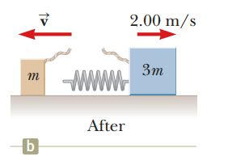
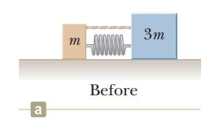

Ans:

- A 90.0-kg fullback running east with a speed of 5.00 m/s is tackled by a 95.0-kg opponent running north with a speed of 3.00 m/s. (a) Explain why the successful tackle constitutes a perfectly inelastic collision. (b) Calculate the velocity of the players immediately after the tackle. (c) Determine the decrease in mechanical energy as a result of the collision. Account for this decrease.
Ans:

- A garden hose is held as shown in Figure P9.32. The hose is originally full of motionless water. What additional force is necessary to hold the nozzle stationary after the water flow is turned on if the discharge rate is 0.600 kg/s with a speed of 25.0 m/s?
Ans:

