Chapter-7
- In 1990, Walter Arfeuille of Belgium lifted a 281.5-kg object through a distance of 17.1 cm using only his teeth. (a) How much work was done on the object by Arfeuille in this lift, assuming the object was lifted at constant speed? (b) What total force was exerted on Arfeuille’s teeth during the lift?
Ans:

- A 7.80-g bullet moving at 575 m/s strikes the hand of a superhero, causing the hand to move 5.50 cm in the direction of the bullet’s velocity before stopping. (a) Use work and energy considerations to find the average force that stops the bullet. (b) Assuming the force is constant, determine how much time elapses between the moment the bullet strikes the hand and the moment it stops moving.
Ans:

- A 0.20-kg stone is held 1.3 m above the top edge of a water well and then dropped into it. The well has a depth of 5.0 m. Relative to the configuration with the stone at the top edge of the well, what is the gravitational potential energy of the stone–Earth system (a) before the stone is released and (b) when it reaches the bottom of the well? (c) What is the change in gravitational potential energy of the system from release to reaching the bottom of the well?
Ans:

- Why is the following situation impossible? A librarian lifts a book from the ground to a high shelf, doing 20.0 J of work in the lifting process. As he turns his back, the book falls off the shelf back to the ground. The gravitational force from the Earth on the book does 20.0 J of work on the book while it falls. Because the work done was 20.0 J 1 20.0 J 5 40.0 J, the book hits the ground with 40.0 J of kinetic energy.
Ans:

Chapter-8
- For saving energy, bicycling and walking are far more efficient means of transportation than is travel by automobile. For example, when riding at 10.0 mi/h, a cyclist uses food energy at a rate of about 400 kcal/h above what he would use if merely sitting still. (In exercise physiology, power is often measured in kcal/h rather than in watts. Here 1 kcal = 1nutritionist’s Calorie = 4 186 J.) Walking at 3.00 mi/h requires about 220 kcal/h. It is interesting to compare these values with the energy consumption required for travel by car. Gasoline yields about 1.30X10⁸ J/gal. Find the fuel economy in equivalent miles per gallon for a person (a) walking and (b) bicycling.
Ans:

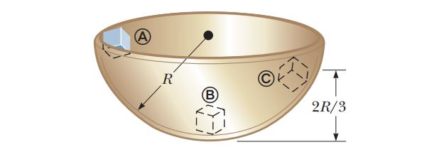
- A block of mass m = 200 g is released from rest at point Ⓐ along the horizontal diameter on the inside of hemispherical bowl of radius R = 30.0 cm, and the surface of the bowl is rough. The block’s speed at point Ⓑ is 1.50 m/s. (a) What is its kinetic energy at point Ⓑ? (b) How much mechanical energy is transformed into internal energy as the block moves from point Ⓐ to point Ⓑ? (c) Is it possible to determine the coefficient of friction from these results in any simple manner? (d) Explain your answer to part (c)

3. As the driver steps on the gas pedal, a car of mass 1 160 kg accelerates from rest. During the first few seconds of motion, the car’s acceleration increases with time according to the expression
a = 1.16t- 0.210t²- 1 0.240t³
where t is in seconds and a is in m/s². (a) What is the change in kinetic energy of the car during the interval from t = 0 to t = 2.50 s? (b) What is the minimum average power output of the engine over this time interval? (c) Why is the value in part (b) described as the minimum value?
Ans:

