**Chapter 31**

1. A 10.0-mH inductor carries a current *i* = *I*max sin *vt*, with *I*max = 5.00 A and *f* = *ω*/2*π* = 60.0 Hz. What is the self-induced emf as a function of time?

Ans:

Using the definition of self-inductance,  we obtain





1. The current in a 4.00 mH-inductor varies in time as shown in Figure P31.8. Construct a graph of the self-induced emf across the inductor over the time interval *t* = 0 to *t* = 12.0 ms.

Ans: 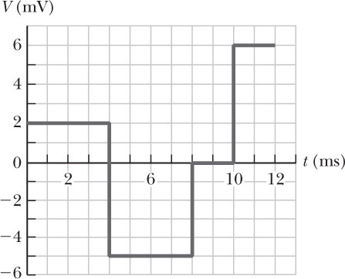

The current change is linear, so 

*t* = 0 to 4 ms:



*t* = 4 to 8 ms:



*t* = 8 to 10 ms:



*t* = 10 to 12 ms:



1. An emf of 24.0 mV is induced in a 500-turn coil when the current is changing at the rate of 10.0 A/s. What is the magnetic flux through each turn of the coil at an instant when the current is 4.00 A?

Ans:

From  we have



From  we have



1. Show that *i=Iie-t/τ* is a solution of the differential equation $iR+L\frac{di}{dt}=0$ where *Ii* is the current at *t* = 0 and *τ* = *L*/*R.*

Ans:

Taking 

 will be true if 

We have agreement because 