**Chapter 30**

1. A circular loop of wire of radius 12.0 cm is placed in a magnetic field directed perpendicular to the plane of the loop as in Figure P30.1. If the field decreases at the rate of 0.050 0 T/s in some time interval, find the magnitude of the emf induced in the loop during this interval.

Ans:

With the field directed perpendicular to the plane of the coil, the flux through the coil is . As the magnitude of the field increases, the magnitude of the induced emf in the coil is



1. A long solenoid has *n* = 400 turns per meter and carries a current given by *I* = 30.0(1-*e-1.60t*), where *I* is in amperes and *t* is in seconds. Inside the solenoid and coaxial with it is a coil that has a radius of *R* = 6.00 cm and consists of a total of *N* = 250 turns of fine wire (Fig. P30.4). What emf is induced in the coil by the changing current?

Ans:

The solenoid creates a magnetic field

B =  = ( N/A2)(400 turns/m)(30.0 A)(1 – e–1.60 t)

B = (1.51  10–2 N/m · A)(1 – e–1.60 t)

The magnetic flux through one turn of the flat coil is  but since dA cos refers to the area perpendicular to the flux, and the magnetic field is uniform over the area A of the flat coil, this integral simplifies to



The emf generated in the N-turn coil is  Because *t* has the standard unit of seconds, the factor 1.60 must have the unit s–1.

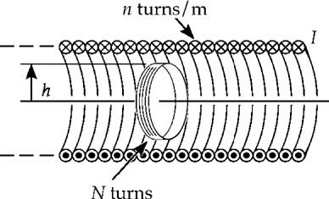

 **ANS. FIG. P30.4**

1. A conducting bar of length , moves to the right on two frictionless rails as shown in Figure P30.15. A uniform magnetic field directed into the page has a magnitude of 0.300 T. Assume *R* = 9.00 V and  = 0.350 m. (a) At what constant speed should the bar move to produce an 8.50-mA current in the resistor? (b) What is the direction of the induced current? (c) At what rate is energy delivered to the resistor? (d) Explain the origin of the energy being delivered to the resistor.

Ans: The motional emf induced in the bar must be  where *I* is the current in this series circuit. Since  the speed of the moving bar must be(b) The flux through the closed loop formed by the rails, the bar, and the resistor is directed into the page and is increasing in magnitude. To oppose this change in flux, the current must flow in a manner so as to produce flux out of the page through the area enclosed by the loop. This means the current will flow 

(c) The rate at which energy is delivered to the resistor is



(d)

1. A toroid having a rectangular cross section (*a* = 2.00 cm by *b* = 3.00 cm) and inner radius *R* = 4.00 cm consists of *N* = 500 turns of wire that carry a sinusoidal current *I* = *I*max sin *ωt*, with *I*max = 50.0 A and a frequency *f* = *ω*/2*π* = 60.0 Hz. A coil that consists of *N*’ = 20 turns of wire is wrapped around one section of the toroid as shown in Figure P30.9. Determine the emf induced in the coil as a function of time

Ans:

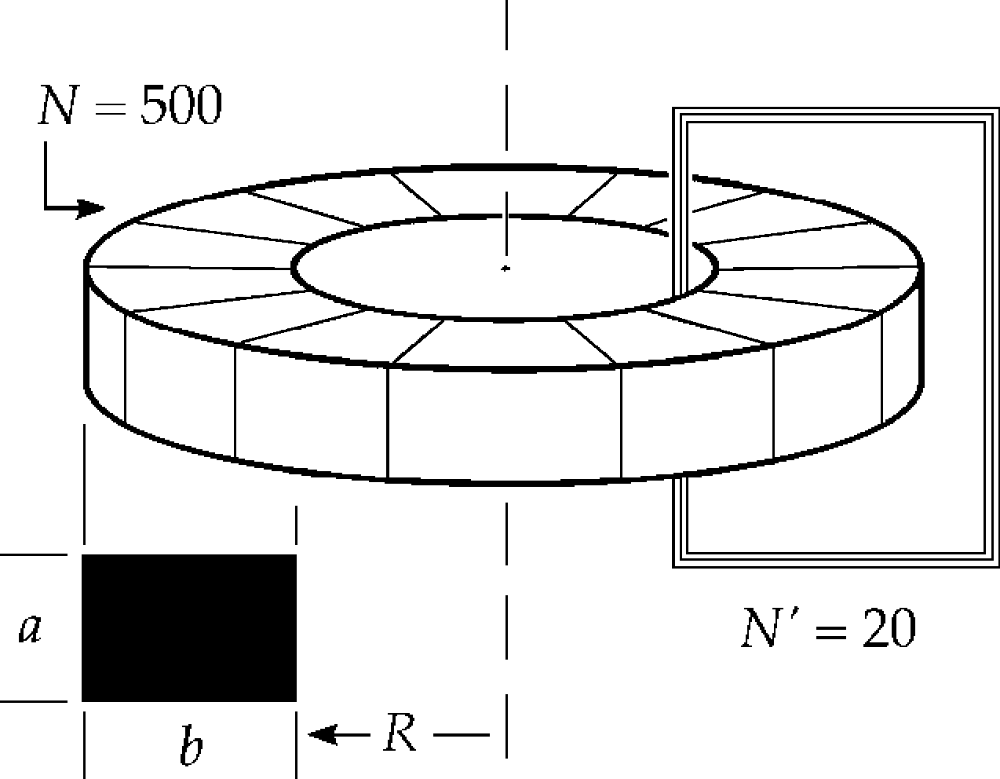In a toroid, all the flux is confined to the inside of the toroid. From Equation 29.16, the field inside the toroid at a distance *r* from its center is



The magnetic flux is then

 **ANS. FIG. P30.9**

and the induced emf is



Substituting numerical values and suppressing units,



