Chapter-29

1. One long wire carries current 30.0 A to the left along the x axis. A second-long wire carries current 50.0 A to the right along the line (y = 0.280 m, z = 0). (a) Where in the plane of the two wires is the total magnetic field equal to zero? (b) A particle with a charge of -2.00 μC is moving with a velocity of 150 i ⁄ Mm/s along the line (y = 0.100 m, z = 0). Calculate the vector magnetic force acting on the particle. (c) What If? A uniform electric field is applied to allow this particle to pass through this region undeflected. Calculate the required vector electric field.

Ans: (a) Above the pair of wires, the field out of the page of the 50.0-A current will be stronger than the  field of the 29.0-A current, so they cannot add to zero. Between the wires, both produce fields into the page. They can only add to zero below the wires, at coordinate *y* = –⎮*y*⎮. Here the total field is

 48573-30-12a2  48573-30-12a3:



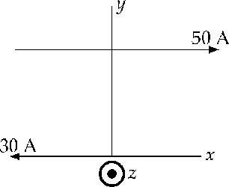

**ANS. FIG. P29.8**

(b) At *y* = 0.100 m the total field is

 48573-30-12b1  48573-30-12b2:



The force on the particle is



(c) We require 

so 

1. Two long wires hang vertically. Wire 1 carries an upward current of 1.50 A. Wire 2, 20.0 cm to the right of wire 1, carries a downward current of 4.00 A. A third wire, wire 3, is to be hung vertically and located such that when it carries certain current, each wire experiences no net force. (a) Is this situation possible? Is it possible in more than one way? Describe (b) the position of wire 3 and (c) the magnitude and direction of the current in wire 3.

Ans: Carrying oppositely directed currents, wires 1 and 2 repel each other. If wire 3 were between them, it would have to repel either 1 or 2, so the force on that wire could not be zero. If wire 3 were to the right of wire 2, it would feel a larger force exerted by 2 than that exerted by 1, so the total force on 3 could not be zero. Therefore wire 3 must be to the left of both other wires as shown. It must carry downward current so that it can attract wire 2. We answer part (b) first.

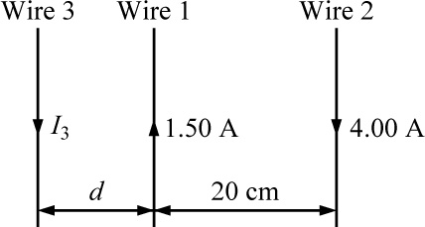

**ANS. FIG. P29.14**

(b) For the equilibrium of wire 3 we have



1.50(20.0 cm + *d*) = 4.00*d*



(a) Thus the situation is possible in just one way.

(c) For the equilibrium of wire 1,





We know that wire 2 must be in equilibrium because the forces on it are equal in magnitude to the forces that it exerts on wires 1 and 3, which are equal because they both balance the equal-magnitude forces that 1 exerts on 3 and that 3 exerts on 1.

1. Consider the hemispherical closed surface in Figure P29.27. The hemisphere is in a uniform magnetic field that makes an angle *θ* with the vertical. Calculate the magnetic flux through (a) the flat surface S1 and (b) the hemispherical surface S2.

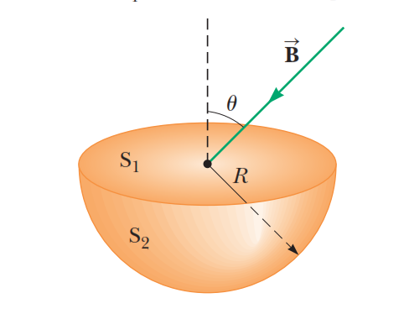

Ans: (a) The magnetic flux through the flat surface *S*1 is



(b) The net flux out of the closed surface is zero: 

Therefore,

