Chapter-27

1. Calculate the power delivered to each resistor in the circuit shown in Figure

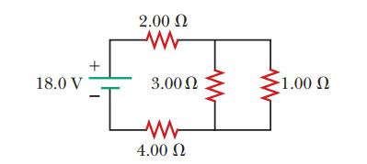

Ans: To find the current in each resistor, we find the resistance seen by the battery. The given circuit reduces as shown in ANS. FIG. P27.13 (a), since



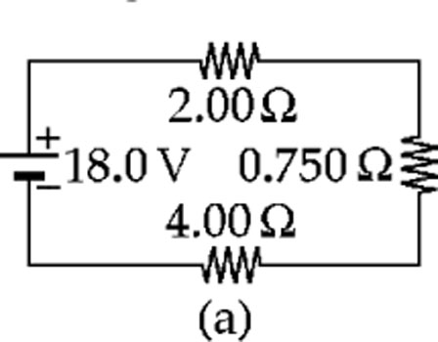

In ANS. FIG. P27.13 (b),

*I* = 18.0 V/6.75 Ω = 2.67 A

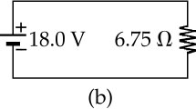 This is also the current in ANS. FIG. P27.13 (a), so  
 the 2.00-Ω and 4.00-Ω resistors convert powers

**

**ANS. FIG. P27.13**

and **

The voltage across the 0.750-Ω resistor in   
ANS. FIG. P27.13 (a), and across both the 3.00-Ω   
and the 1.00-Ω resistors in Figure P27.13, is

**

Then for the 3.00-Ω resistor,



and the power is



For the 1.00-Ω resistor,



1. The following equations describe an electric circuit:

-I1 (220 Ω) + 5.80 V - I2 (370 Ω) = 0

+I2 (370 Ω) + I3 (150 Ω) - 3.10 V = 0

I1 + I3 - I2 = 0

(a) Draw a diagram of the circuit. (b) Calculate the unknowns and identify the physical meaning of each unknown.

Ans: (a) The first equation represents Kirchhoff’s loop theorem. We choose to think of it as describing a clockwise trip around the left-hand loop in a circuit; see ANS. FIG. P27.18(a).

For the right-hand loop see ANS. FIG. P28.18(b). The junctions must be between the 5.80-V emf and the 370-Ω resistor and between the 370-Ω resistor and the 150-Ω resistor. Then we have ANS. FIG. P28.18(c). This is consistent with the third equation,

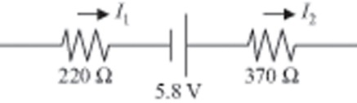

**ANS. FIG. P27.18(a)**



(b) Suppressing units, we substitute:

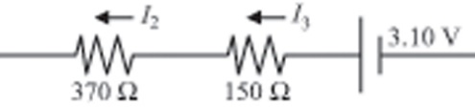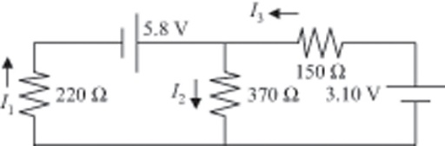

**ANS. FIG. P27.18(b)**

**ANS. FIG. P27.18(c)**



Next , 



1. A 10.0-mF capacitor is charged by a 10.0-V battery through a resistance R. The capacitor reaches a potential difference of 4.00 V in a time interval of 3.00 s after charging begins. Find R.

Ans: The potential difference across the capacitor is



Using 1 farad = 1 s/Ω,



Therefore,



or 

Taking the natural logarithm of both sides,



and 