Chapter-27
- Calculate the power delivered to each resistor in the circuit shown in Figure
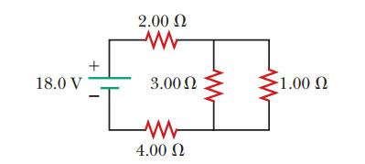

- The following equations describe an electric circuit:
-I₁ (220 Ω) + 5.80 V - I₂ (370 Ω) = 0
+I₂ (370 Ω) + I₃ (150 Ω) - 3.10 V = 0
I₁ + I₃ - I₂ = 0
(a) Draw a diagram of the circuit. (b) Calculate the unknowns and identify the physical meaning of each unknown.

- A 10.0-mF capacitor is charged by a 10.0-V battery through a resistance R. The capacitor reaches a potential difference of 4.00 V in a time interval of 3.00 s after charging begins. Find R.

