Chapter-22
- Two small beads having charges q1 and q2 of the same sign are fixed at the opposite ends of a horizontal insulating rod of length d. The bead with charge q1 is at the origin. As shown in Figure P22.8, a third small, charged bead is free to slide on the rod. (a) At what position x is the third bead in equilibrium? (b) Can the equilibrium be stable?
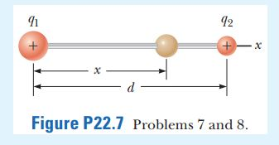
Ans:

- Two charged particles are located on the x axis. The first is a charge +Q at x = -a. The second is an unknown charge located at x = +3a. The net electric field these charges produce at the origin has a magnitude of 2k_{e}Q /a². Explain how many values are possible for the unknown charge and find the possible values.
Ans:

- A proton moves at 4.50 X 10⁵ m/s in the horizontal direction. It enters a uniform vertical electric field with a magnitude of 9.60 X10³ N/C. Ignoring any gravitational effects, find (a) the time interval required for the proton to travel 5.00 cm horizontally, (b) its vertical displacement during the time interval in which it travels 5.00 cm horizontally, and (c) the horizontal and vertical components of its velocity after it has traveled 5.00 cm horizontally.
Ans:

