**Chapter-17**

1. A taut string has a length of 2.60 m and is fixed at both ends. (a) Find the wavelength of the fundamental mode of vibration of the string. (b) Can you find the frequency of this mode? Explain why or why not.

Ans: (a) Because the string is taut and is fixed at both ends, any standing waves will have nodes (which are multiples of *λ*/2 apart). The wavelengths of all possible modes on the string are:

 where *n* = 1, 2, 3,…

The fundamental (n = 1) wavelength must then have a wavelength *λ* exactly twice the string length, or



(b)  To obtain the frequencies on the string,



it is necessary to have either the wave velocity *v* or the tension T and mass density *µ* of the string. We do not know these; therefore, it is not possible to find the frequency of this mode on the string.

1. An air column in a glass tube is open at one end and closed at the other by a movable piston. The air in the tube is warmed above room temperature, and a 384-Hz tuning fork is held at the open end. Resonance is heard when the piston is at a distance d1= 22.8 cm from the open end and again when it is at  
   a distance d2 = 68.3 cm from the open end. (a) What speed of sound is implied by these data? (b) How far from the open end will the piston be when the next resonance is heard?

Ans: For resonance in a narrow tube open at one end,

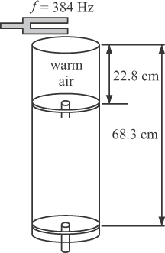 

(a) The node–node distance is

dNN = 68.3 cm – 22.8 cm = 45.5 cm

This distance is equal to half the wavelength, so,



(b) Resonance will be established when the tube length has increased by another half wavelength: 68.3 cm + 45.5 = 113.8 = 

1. **Review.** A student holds a tuning fork oscillating at 256 Hz. He walks toward a wall at a constant speed of 1.33 m/s. (a) What beat frequency does he observe between the tuning fork and its echo? (b) How fast must he walk away from the wall to observe a beat frequency of 5.00 Hz?

Ans: The source moves toward the wall:

*v*s = +*v*student, *v*0 = 0, and 

The wall acts as stationary source, reflecting the wave of frequency  The observe moves toward the source: *v*s = 0, *v*0 = +*v*student, and



(a) When the student walks toward the wall  is larger than *f*; the beat frequency is





(b) When he is moving away from the wall, the sign of *v*student changes and  is smaller than f:



Solving for *v*student gives

