**Chapter -12**

1. 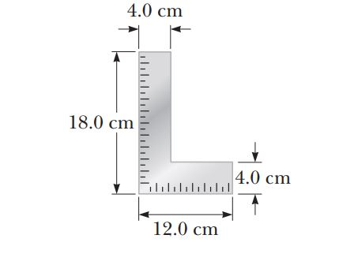A carpenter’s square has the shape of an L as shown in Figure. Locate its center of gravity.

Ans:

The coordinates of the center of gravity of piece 1 are

 and 

The coordinates for piece 2 are

 and 

The area of each piece is

 and 

And the mass of each piece is proportional to the area.

Thus,



and



1. A uniform beam of length 7.60 m and weight 4.50 x 102 N is carried by two workers, Sam and Joe, as shown in Figure P12.6. Determine the force that each person exerts on the beam.

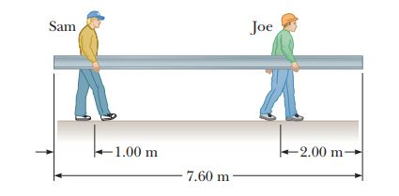

Ans:

Since the beam is in equilibrium, we choose the center as our pivot point and require that



or

 **[1]**

Also,

 **[2]**

Substitute equation [1] into [2] to get the following:

 or 

Then, equation [1] yields 



1. The deepest point in the ocean is in the Mariana Trench, about 11 km deep, in the Pacific. The pressure at this depth is huge, about 1.13 x 108 N/m2. (a) Calculate the change in volume of 1.00 m3 of seawater carried from the surface to this deepest point. (b) The density of seawater at the surface is 1.03 x 103 kg/m3. Find its density at the bottom. (c) Explain whether or when it is a good approximation to think of water as incompressible.

Ans:

We use .

(a) 

(b) The quantity of water with mass  occupies volume at the bottom: 

So its density is  

(c) 

1. Assume if the shear stress in steel exceeds about 4.00 x 108 N/m2, the steel ruptures. Determine the shearing force necessary to (a) shear a steel bolt 1.00 cm in diameter and (b) punch a 1.00-cm-diameter hole in a steel plate 0.500 cm thick.

Ans:

(a) From ANS. FIG. ****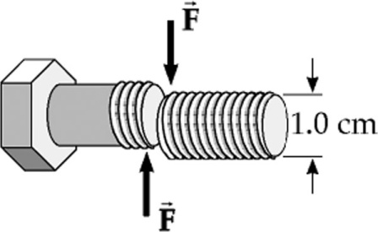**

**P12.31(a),**

(b) Now the area of the molecular layers sliding over each other is the curved lateral surface area of the cylinder being punched out, a cylinder of radius 0.500 cm and height 0.500 cm. So,

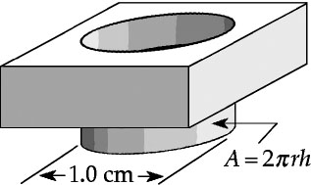

ANS. FIG. P12.21(b)