Chapter -12
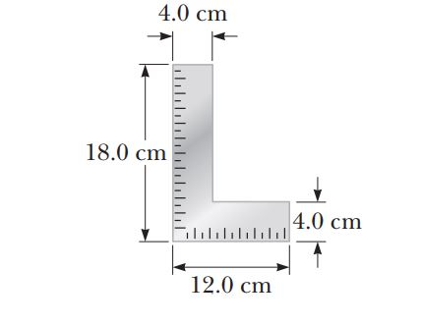
- A carpenter’s square has the shape of an L as shown in Figure. Locate its center of gravity.
Ans:

- A uniform beam of length 7.60 m and weight 4.50 x 10² N is carried by two workers, Sam and Joe, as shown in Figure P12.6. Determine the force that each person exerts on the beam.
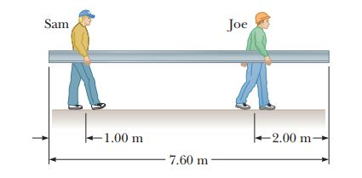

Ans:

- The deepest point in the ocean is in the Mariana Trench, about 11 km deep, in the Pacific. The pressure at this depth is huge, about 1.13 x 10⁸ N/m². (a) Calculate the change in volume of 1.00 m³ of seawater carried from the surface to this deepest point. (b) The density of seawater at the surface is 1.03 x 10³ kg/m³. Find its density at the bottom. (c) Explain whether or when it is a good approximation to think of water as incompressible.
Ans:

- Assume if the shear stress in steel exceeds about 4.00 x 10⁸ N/m², the steel ruptures. Determine the shearing force necessary to (a) shear a steel bolt 1.00 cm in diameter and (b) punch a 1.00-cm-diameter hole in a steel plate 0.500 cm thick.
Ans:

