**Chapter 1**

1. Two spheres are cut from a certain uniform rock. One has radius 4.50 cm. The mass of the other is five times greater. Find its radius.

Ans:

For either sphere the volume is  and the mass is  We divide this equation for the larger sphere by the same equation for the smaller:



Then 

1. An auditorium measures 40.0 m X 20.0 m X 12.0 m. The density of air is 1.20 kg/m2. What are (a) the volume of the room in cubic feet and (b) the weight of air in the room in pounds?

Ans:

(a) To obtain the volume, we multiply the length, width, and height of the room, and use the conversion 1 m = 3.281 ft.

**

(b) The mass of the air is

**

The student must look up the definition of weight in the index to find

**

where the unit of N of force (weight) is newtons.

Converting newtons to pounds,



**Chapter 2**

1. 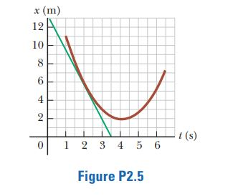A position–time graph for a particle moving along the x axis is shown in Figure P2.5. (a) Find the average velocity in the time interval t = 1.50 s to t = 4.00 s. (b) Determine the instantaneous velocity at t = 2.00 s by measuring the slope of the tangent line shown in the graph. (c) At what value of t is the velocity zero?

Ans:

For average velocity, we find the slope of a secant line running across the graph between the 1.5-s and 4-s points. Then for instantaneous velocities we think of slopes of tangent lines, which means the slope of the graph itself at a point.

We place two points on the curve: Point A, at   
*t* = 1.5 s, and Point B, at *t* = 4.0 s, and read the corresponding values of *x*.

(a) At *ti* = 1.5 s, *xi* = 8.0 m (Point A)

At *tf* = 4.0 s, *xf* = 2.0 m (Point B)



(b) The slope of the tangent line can be found from points *C* and *D*. (*tC* = 1.0 s, *xC* = 9.5 m) and (*tD* = 3.5 s, *xD* = 0),



The negative sign shows that the **direction** of *vx*is along the negative *x* direction.

(c) The velocity will be zero when the slope of the tangent line is zero. This occurs for the point on the graph where *x* has its minimum value. This is at .

Chapter 3

1. 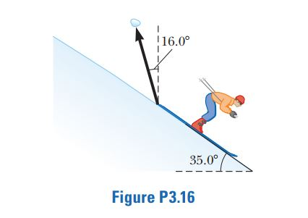A snow-covered ski slope makes an angle of 35.0o with the horizontal. When a ski jumper plummets onto the hill, a parcel of splashed snow is thrown up to a maximum displacement of 1.50 m at 16.0o from the vertical in the uphill direction as shown in Figure P3.16. Find the components of its maximum displacement (a) parallel to the surface and (b) perpendicular to the surface

Ans:

We take the x axis along the slope downhill. (Students, get used to this choice!) The y axis is perpendicular to the slope, at 35.0° to the vertical. Then the displacement of the snow makes an angle of 90.0° + 35.0° + 16.0° = 141° with the x axis.

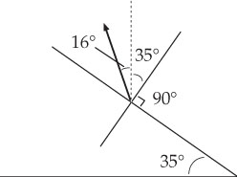

ANS. FIG. P3.16

(a) 

(b) 

**Chapter 4**

1. The vector position of a particle varies in time according to the expression $\vec{r}$ = 3.00 - 6.00*t*2 , where is in meters and *t* is in seconds. (a) Find an expression for the velocity of the particle as a function of time. (b) Determine the acceleration of the particle as a function of time. (c) Calculate the particle’s position and velocity at *t* = 1.00 s.

Ans:

(a) We differentiate the equation for the vector position of the particle with respect to time to obtain its velocity:



(b) Differentiating the expression for velocity with respect to time gives the particle’s acceleration:



(c) By substitution, when t = 1.00 s,



**Chapter 5**

1. The force exerted by the wind on the sails of a sailboat is390 N north. The water exerts a force of 180 N east. If the boat (including its crew) has a mass of 270 kg, what are the magnitude and direction of its acceleration?

Ans:

Since the two forces are perpendicular to each other, their resultant is



at an angle of



From Newton’s second law,



or



**Chapter 6**

1. A hawk flies in a horizontal arc of radius 12.0 m at constant speed 4.00 m/s. (a) Find its centripetal acceleration. (b) It continues to fly along the same horizontal arc, but increases its speed at the rate of 1.20 m/s2. Find the acceleration (magnitude and direction) in this situation at the moment the hawk’s speed is 4.00 m/s.

Ans:

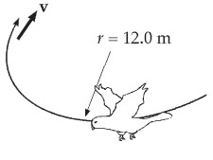 (a) The hawk’s centripetal acceleration is



(b) The magnitude of the acceleration vector is



at an angle

