Chapter 1
- Two spheres are cut from a certain uniform rock. One has radius 4.50 cm. The mass of the other is five times greater. Find its radius.
Ans:

- An auditorium measures 40.0 m X 20.0 m X 12.0 m. The density of air is 1.20 kg/m². What are (a) the volume of the room in cubic feet and (b) the weight of air in the room in pounds?
Ans:

Chapter 2
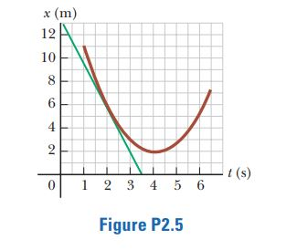
- A position–time graph for a particle moving along the x axis is shown in Figure P2.5. (a) Find the average velocity in the time interval t = 1.50 s to t = 4.00 s. (b) Determine the instantaneous velocity at t = 2.00 s by measuring the slope of the tangent line shown in the graph. (c) At what value of t is the velocity zero?

Chapter 3
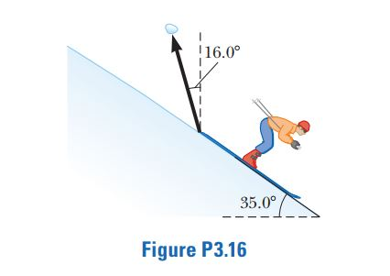
- A snow-covered ski slope makes an angle of 35.0º with the horizontal. When a ski jumper plummets onto the hill, a parcel of splashed snow is thrown up to a maximum displacement of 1.50 m at 16.0º from the vertical in the uphill direction as shown in Figure P3.16. Find the components of its maximum displacement (a) parallel to the surface and (b) perpendicular to the surface

Ans:

Chapter 4
- The vector position of a particle varies in time according to the expression $\vec{r}$ = 3.00$\hat{i}$ - 6.00t² $\hat{j}$, where $\vec{r }$is in meters and t is in seconds. (a) Find an expression for the velocity of the particle as a function of time. (b) Determine the acceleration of the particle as a function of time. (c) Calculate the particle’s position and velocity at t = 1.00 s.

Chapter 5
- The force exerted by the wind on the sails of a sailboat is390 N north. The water exerts a force of 180 N east. If the boat (including its crew) has a mass of 270 kg, what are the magnitude and direction of its acceleration?

Chapter 6
- A hawk flies in a horizontal arc of radius 12.0 m at constant speed 4.00 m/s. (a) Find its centripetal acceleration. (b) It continues to fly along the same horizontal arc, but increases its speed at the rate of 1.20 m/s². Find the acceleration (magnitude and direction) in this situation at the moment the hawk’s speed is 4.00 m/s.
