**Chapter 30. Sources of the Magnetic Fields**

St. ID: , Name:

1. In Niels Bohr’s 1913 model of the hydrogen atom, an electron circles the proton at a distance of 5.29**╳**10-11 m with a speed of 2.19**╳**106 m/s. Compute the magnitude of the magnetic field this motion produces at the location of the proton.

Ans: 12.5 T

Treat the magnetic field as that produced in the center of a ring of radius *R* carrying current *I*: from Equation 29.8, the field is  The current due to the electron is



so the magnetic field is



1. Determine the magnetic field (in terms of *I*, *a*, and *d*) at the origin due to the current loop in Figure P29.9. The loop extends to infinity above the figure.

Ans: $\frac{μ_{0}I}{2ad}\sqrt{a^{2}+d^{2}}-d$

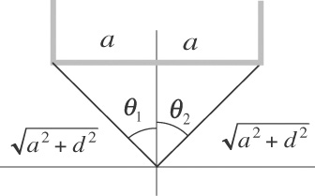Apply the Equation 29.4,, to each of the wires. For the horizontal wire (*H*), and  because  measures to the wire’s end point on the –*x*-axis and  measures to the wire’s end point on the +*x*-axis. For the left vertical wire (*VL*) and the right vertical wire (*VR*),  and sin = 1 because both angles measure to the wire’s end points on the +*y*-axis.

**ANS. FIG. P29.9**

Take out of the page as the positive direction, and into the page as the negative direction. The field at the origin is



The field is negative: magnetic field at the origin is  into the page.

1. A long, cylindrical conductor of radius *R* carries a current *I* as shown in Figure P29.22. The current density *J*, however, is not uniform over the cross section of the conductor but rather is a function of the radius according to *J* = *br*, where *b* is a constant. Find an expression for the magnetic field magnitude *B* (a) at a distance *r*1 >*R* and (b) at a distance *r*2 >*R*, measured from the center of the conductor.

Ans: (a) $\frac{1}{3}(μ_{0}{{br}_{1}}^{2})$ inside (b) $μ_{0}bR^{3}/3r_{2}$ outisde

Take a circle of radius *r*1 or *r*2 to apply  where for non-uniform current density  In this case is parallel to and the direction of *J*is straight through the area element *dA*, so Ampère’s law gives



1. For *r*1 < *R*,



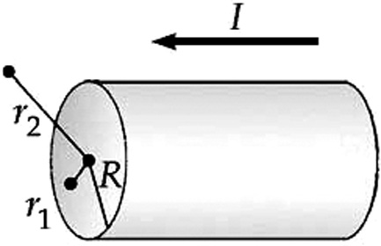 **ANS. FIG. P29.22**

And 

1. For *r*2 > *R*,



And 

1. Consider the hemispherical closed surface in Figure P29.27. The hemisphere is in a uniform magnetic field that makes an angleθwith the vertical. Calculate the magnetic flux through the flat surface S1 and (b) the hemispherical surface S2.

Ans: (a) (ΦB)flat = -BπR2cosθ (b) (ΦB)curved =BπR2cosθ

1. The magnetic flux through the flat surface *S*1 is



1. The net flux out of the closed surface is zero: 

Therefore,

