**Chapter 29. Magnetic Fields**

St. ID: , Name:

1. Find the direction of the magnetic field acting on a positively charged particle moving in the various situations shown in Figure P28.3 if the direction of the magnetic force acting on it is as indicated.

Ans: (a) into the page (b) toward the right (c) toward the bottom of the page

To find the direction of the magnetic field, we use $\overset{⃑}{F_{B}}=q\overset{⃑}{v}×\overset{⃑}{B}$. Since the particle is positively charged, we can use the right hand rule. In this case, we start with the fingers of the right hand in the direction of $\overset{⃑}{v}$ and the thumb pointing in the direction of $\overset{⃑}{F}$. As we start closing the hand, our fingers point in the direction of $\overset{⃑}{B}$ after they have moved 90°. The results are

(a)  (b)  (c) 

1. A proton travels with a speed of 5.02 × 106 m/s in a direction that makes an angle of 60.0° with the direction of a magnetic field of magnitude 0.180 T in the positive *x* direction. What are the magnitudes of (a) the magnetic force on the proton and (b) the proton’s acceleration?

Ans: (a) 1.25×10-13 N (b) 7.50×1013 m/s2

(a) The magnetic force is given by

(b) From Newton’s second law,



1. An electron moves in a circular path perpendicular to a constant magnetic field of magnitude 1.00 mT. The angular momentum of the electron about the center of the circle is 4.00 × 10-25 kg⸳m2/s. Determine (a) the radius of the circular path and (b) the speed of the electron

Ans: (a) R= 5.00 cm (b) v=8.78×106 m/s

1. We begin with, or *qRB* = *mv.* But, *L* = *mvR* = *qR*2*B.*

Therefore,



(b) Thus, 

1. A strong magnet is placed under a horizontal conducting ring of radius *r* that carries current *I* as shown in Figure P28.27. If the magnetic field $\overset{⃑}{B}$ makes an angle θ with the vertical at the ring’s location, what are (a) the magnitude and (b) the direction of the resultant magnetic force on the ring?

Ans: (a) 2πrlBsinθ (b) up, away from magnet

(a) Refer to ANS. FIG. P28.27. The magnetic field is perpendicular to all line elements  on the ring, so the magnetic force  on each element has magnitude  and is radially inward and upward, at angle *θ* above the radial line. The radially inward components *IdsB* cos*θ* tend to squeeze the ring but all cancel out because forces on opposite sides of the ring cancel in pairs. The upward components *IdsB* sin*θ* all add to .

(a) magnitude: 

(b) direction: 

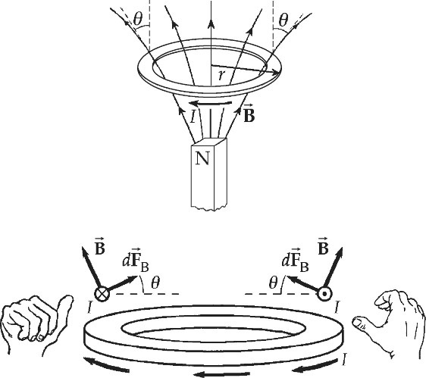

**ANS. FIG. P28.27**