Chapter 27. Current and Resistance

St. ID: , Name:

1. (a) In the Bohr model of the hydrogen atom (which will be covered in detail in Chapter 41), an electron in the lowest energy state moves at a speed of 2.19 × 10⁶ m/s in a circular path of radius 5.29 × 10⁻¹¹ m. What is the effective current associated with this orbiting electron?
Ans: 1.05 mA

2. The quantity of charge q (in coulombs) that has passed through a surface of area 2.00 cm² varies with time according to the equation$q=4t^{3}+5t+6$, where t is in seconds. (a) What is the instantaneous current through the surface at t =1.00 s? (b) What is the value of the current density?
Ans: (a) 17.0 A (b) 85.0 kA/m²

3. An electric current in a conductor varies with time according to the expression$I\left(t\right)=100sin⁡(120t)$, where I is in amperes and t is in seconds. What is the total charge passing a given point in the conductor from$t=0$ to$t=1/240s$?
Ans: 0.265C

4. A wire 50.0 m long and 2.00 mm in diameter is connected to a source with a potential difference of 9.11 V, and the current is found to be 36.0 A. Assume a temperature of 20.08C and, using Table 26.2, identify the metal out of which the wire is made.
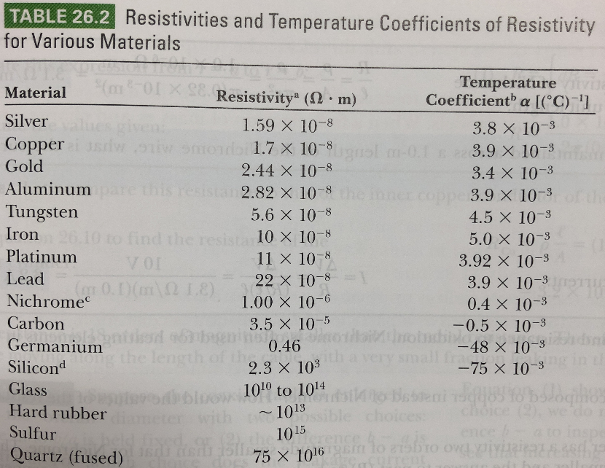
Ans: Silver

Table 26.2

