**Chapter 26. Capacitance and Dielectrics**

St. ID: , Name:

1. (a) When a battery is connected to the plates of a 3.00-*m*F capacitor, it stores a charge of 27.0 **C. What is the voltage of the battery? (b) If the same capacitor is connected to another battery and 36.0 **C of charge is stored on the capacitor, what is the voltage of the battery?

Ans: (a) 9.00V (b) 12.0V

(a) From Equation 25.1 for the definition of capacitance,  we have



(b) Similarly,



2. An air-filled parallel-plate capacitor has plates of area 2.30 cm2 separated by 1.50 mm. (a) Find the value of its capacitance. The capacitor is connected to a 12.0-V battery. (b) What is the charge on the capacitor? (c) What is the magnitude of the uniform electric field between the plates?

Ans: (a) 1.36 pF (b) 16.3 pC (c) 8.00×103 V/m (p=pico 10-12)

(a) 

(b) 

(c) 

3. Find the equivalent capacitance between points *a* and *b* in the combination of capacitors shown in Figure P25.13.

Ans: 12.9 F



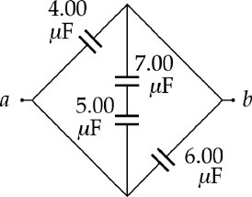

**ANS. FIG. P25.13**

4. Find the equivalent capacitance of a 4.20-*m*F capacitor and an 8.50-*m*F capacitor when they are connected (a) in series and (b) in parallel.

Ans: (a) 2.81 F (b) 12.70 F

(a) When connected in series, the equivalent capacitance is , or



(b) When connected in parallel, the equivalent capacitance is

