**Chapter 25. Electric potential**

St. ID: , Name:

1. How much work is done (by a battery, generator, or some other source of potential difference) in moving Avogadro’s number of electrons from an initial point where the electric potential is 9.00 V to a point where the electric potential is 25.00 V? (The potential in each case is measured relative to a common reference point.)

Ans: 1.35MJ = 1.35x106 J

The potential difference is



and the total charge to be moved is



Now, from  we obtain



1. Three positive charges are located at the corners of an equilateral triangle as in Figure P24.7. Find an expression for the electric potential at the center of the triangle.

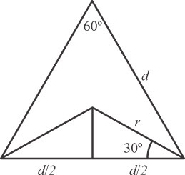Ans: 6.93keQ/d

By symmetry, a line from the center to each vertex forms a 30° angle with each side of the triangle. The figure shows the relationship between the length *d* of a side of the equilateral triangle and the distance *r* from a vertex to the center:



The electric potential at the center is



**ANS. FIG. P24.7**

1. 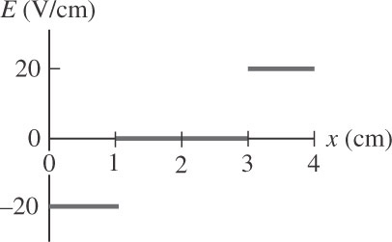Figure P24.22 represents a graph of the electric potential in a region of space versus position *x*, where the electric field is parallel to the *x* axis. Draw a graph of the *x* component of the electric field versus *x* in this region.

Ans:



The sign indicates the direction of the *x* component of the field.

*x* = 0 to 1 cm

 **ANS. FIG. P24.22**

*x* = 1 to 3 cm: 

*x* = 3 to 4 cm: 

‘

1. The two charges in Figure P24.12 are separated by a distance *d* = 2.00 cm, and *Q* = +5.00 nC. Find (a) the electric potential at *A*, (b) the electric potential at *B*, and (c) the electric potential difference between *B* and *A.*

Ans: (a) 5.43kV (b) 6.08kV (c) 658V

(a) 



(b) 



(c) 

.