**Chapter 25. Electric potential**

St. ID: , Name:

1. How much work is done (by a battery, generator, or some other source of potential difference) in moving Avogadro’s number of electrons from an initial point where the electric potential is 9.00 V to a point where the electric potential is 25.00 V? (The potential in each case is measured relative to a common reference point.)

Ans: 1.35MJ = 1.35x106 J

1. Three positive charges are located at the corners of an equilateral triangle as in Figure P24.7. Find an expression for the electric potential at the center of the triangle.

Ans: 6.93keQ/d

**Figure P24.7.**

1. Figure P24.22 represents a graph of the electric potential in a region of space versus position *x*, where the electric field is parallel to the *x* axis. Draw a graph of the *x* component of the electric field versus *x* in this region.

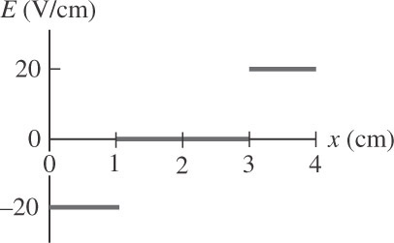Ans:

1. The two charges in Figure P24.12 are separated by a distance *d* = 2.00 cm, and *Q* = +5.00 nC. Find (a) the electric potential at *A*, (b) the electric potential at *B*, and (c) the electric potential difference between *B* and *A.*

Ans: (a) 5.43kV (b) 6.08kV (c) 658V

**Figure P24.12**